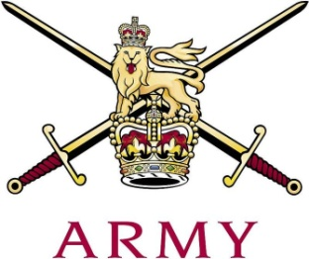
ARMY CRESTA

Scots Guards Cup 2020

Ser | Name | Regiment | 1st  Course | 2nd  Course | Total
1 | Maj PJR Chishick | The Life Guards | 53.80 | 54.37 | 108.17
2 | Capt T Wythe | The Royal Lancers, (Queen Elizabeths' Own) | 54.16 | 54.30 | 108.46
3 | Maj JB Barnes | The Blues & Royals | 55.64 | 54.60 | 110.24
4 | Capt J Palmer-Tomkinson | 1st Battalion Grenadier Guards | 56.73 | 56.70 | 113.43
5 | LCoH R Tonkin | The Blues & Royals | 57.10 | 57.19 | 114.29
6 | Capt S Pryor | The King's Royal Hussars | 58.01 | 57.77 | 115.78
7 | LCpl W Fairbairn | The Blues & Royals | 58.76 | 57.67 | 116.43
8 | Lt G.Packe-Drury-Lowe | The Royal Army Medical Corps | Fall (S) | 55.08
9 | 2Lt C.Evans | 7 The Rifles | Fall (S) | 69.28
