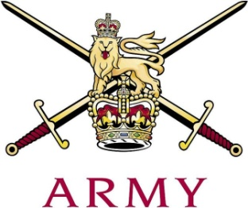
ARMY CRESTA

Junction Handicap 2020
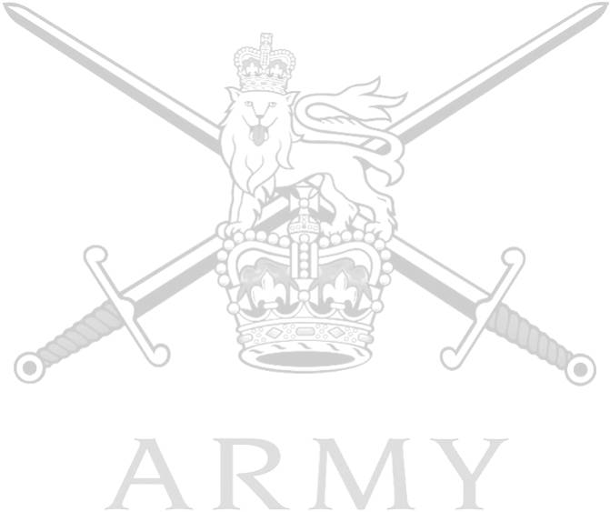
Ser | Name | Regiment | H’Cap | 1st | 2nd | Net Total
1 | Tpr C Burnett | The Blues and Royals | 2.9 | 46.78 | 47.27 | 88.25
2 | Tpr TR Wraight | The Life Guards | 2.8 | 48.12 | 48.13 | 90.65
3 | 2 Lt T Muir | The Life Guards | 4.5 | 49.64 | 50.70 | 91.34
4 | 2 Lt S Kaye | The Life Guards | 3 | 49.20 | 48.55 | 91.75
5 | Maj JB Barnes | The Blues and Royals | + 1.8 | 44.35 | 44.35 | 92.30
6 | LCpl W Fairbairn | The Blues and Royals | Scr | 46.34 | 46.34 | 92.68
7 | Lt BH Vickers | Army Air Corps | 4.5 | 50.02 | 52.37 | 93.39
8 | Tpr AR Price | Royal Lancers | 4.5 | 49.62 | 52.83 | 93.45
9 | LCoH R Tonkin | The Blues and Royals | + 0.5 | 46.26 | 46.26 | 93.52
10 | Capt T Wythe | Royal Lancers | + 3.0 | 43.96 | 43.96 | 93.92
11 | Tpr C Jacques-Smith | Royal Lancers | 6.2 | 52.54 | 53.84 | 93.98
12 | Capt S Pryor | Kings Royal Hussars | + 1.5 | 45.49 | 45.49 | 93.98
13 | Maj PJR Chishick | The Life Guards | + 1.5 | 45.61 | 45.61 | 94.22
14 | Capt CJ Hartland | Army Air Corps | 4.5 | 51.64 | 51.98 | 94.62
15 | Tpr B Marks | Kings Royal Hussars | 10 | 57.66 | 57.01 | 94.67
 | Cpl I Leigh | Intelligence Corps | 8 | 55.27 | 57.75 | 97.02
 | Tpr B Thompson | Royal Lancers | 10 | 61.65 | 62.50 | 104.15
 | Tpr MG Keith | Scots Dragoon Guards | 10 | 66.83 | 59.14 | 105.97
 | Capt SS Brown | Scots Dragoon Guards | 10 | 62.01 | 65.48 | 107.49
 | Lt F Howes | Intelligence Corps | 10 | 64.81 | 67.96 | 112.77
 | Capt DW Titcomb | Royal Lancers | 3.5 | 49.02 | Fall (S)
 | 2 Lt RKM Lewis | 3 SCOTS | 8 | 54.08 | Fall (S)
 | 2 Lt ERM Smith | 3 SCOTS | 8 | 56.14 | Fall (S)
 | Capt JII Ramsey | 3 SCOTS | 10 | 57.07 | Fall (S)
 | Capt NJT Coles | 3 SCOTS | 8 | 61.76 | Fall (S)
 | Lt H Fair | Kings Royal Hussars | 6.5 | Fall (S)
 | Lt A Nichol | Kings Royal Hussars | 10 | Fall (S)
 | Tpr B Matanle | Kings Royal Hussars | 10 | Fall (S)

