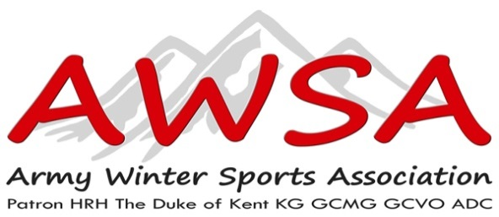
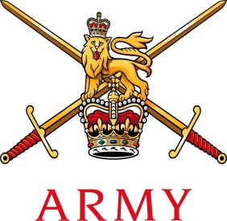

Col Stefan B Crossfield
Director Ice Sports
Mobile: 07952 947772
Army Winter Sports Association
Army Sports Control Board
MacKenzie Building, Fox Lines
Queens Avenue
Aldershot GU 11 2 LG
Email:DirectorIcesports@awsa.org.uk
T+44(0)1252 78 7078 Mil 94222 7078
F+44(0)1252 78 7079 Mil 94222 7079

12/07/2018

Army Bobsleigh, Luge and Skeleton Associations.

Coaching Directive 2018/2019

Introduction.
Due to current changes of public liability and insurance for civilian and military coaches teaching Ice Sports to military personnel we have been forced to implement changes of how we do business when it comes to employment and responsibility to other parties. This has also be brought to the fore by the recent and unfortunate accident at Igls involving ice sports.

For the forthcoming season 2018/2019 each civilian and military coach will hold a AWSA Ice Sports Coaches log book (ISCLB) along with a ASWA Competent Ice Sports Coaches ID (CISCID) card which will be signed by Director Ice Sports on behalf of The AWSA

Each coach will be issued Log book which is to be completed after each day’s sliding with a short and brief description of instruction given, progression of students within their discipline. It is also to include any concerns on the matter of safety, accidents or crashes, students not deemed competent within their disciplines and actions taken.

The AWSA IS log will be used as a coach’s progression record and when proven to be a competent coach will be progressed to the next level of coaching. Each coach must be reviewed by a level A class coach and chairman of each individual discipline to progress to the next level of coaching. This will be reviewed by a level A coach at the end of each weeks sliding and signed on the last page of that week.

For the purpose of coaching there will be three class levels of standard.

A Coach. Head coach for each discipline. Must have international sliding experience and have represented UK at either Olympic Winter Games, World Cup (FIL) (IBSF). Must have had a minimum of five years’ experience in coaching at Army and Inter Services level. He or She must be able and competent in methods of instruction.

B Coach. Assistant coach for each discipline. Must have sliding experience up junior standard at national/international level, Nations cup in Luge or Europa cup in Bobsleigh and Skeleton, represented the Army Inter services at least on three occasions, have proven track experience, competent at explaining and teaching the basics of sliding and sled set up.

C Coach. Third coach for each discipline. Must have been or still a competent slider at Army, Inter services level. Be able to explain the basics of sliding and sled set up. Be able to assist A and B coaches to gain experience. Full knowledge of equipment held by discipline and has a basic idea of equipment maintenance and repair.

Pay and Incentives
For the season 2015/2016 civilian coach’s pay will be a standardized for all disciplines, this will be reviewed at the beginning of each season. All hotel cost for half board will be paid from AWSA funds.

Pay per week will be £450.00 this will also cover the missed lunch time meal.
Civilian coaches will only be able to claim motor mileage from their home location to departure location at the rate of .25p per mile. Any flights that have to be taken will be paid for by AWSA funds.

Coaches for ice sports are now becoming a rare commodity and we are very dependent on the good will of our regular civilians who help us each year and will continue to do so for the foreseeable future.

However, we must all look to the future and were we will stand in five years’ and beyond. Each discipline needs to be looking for potential personnel not only for coaching purposes but for future sectaries and chairman, some of the more seasoned service veterans need to be giving back to the sport what they have be lucky enough to have benefited and taken part in. I must point out that these need to be volunteers who are willing to give 100% not pressganged into a position they are not happy with.

Coaches, civilians and military our encouraged to keep their ISCLB up to date daily, these will be looked at come the end of each season and reviewed by Director ice and a selected board. Each ISCLB holder will be judged on input and instruction given by their ISCLB and given a £100.00 bonus for their seasons work if their input has been deemed satisfactory.
Once a coach at levels B, C has gained experience and knowledge they will be reviewed by a selected board of A coaches and discipline staff, if selected to be given the next standard of coaching they will be given a £200.00 bonus.

WO2 GR Holmes
May 2018

