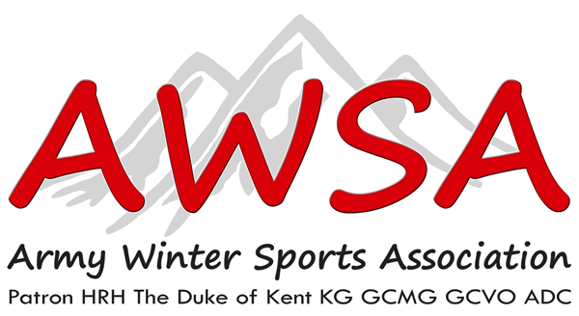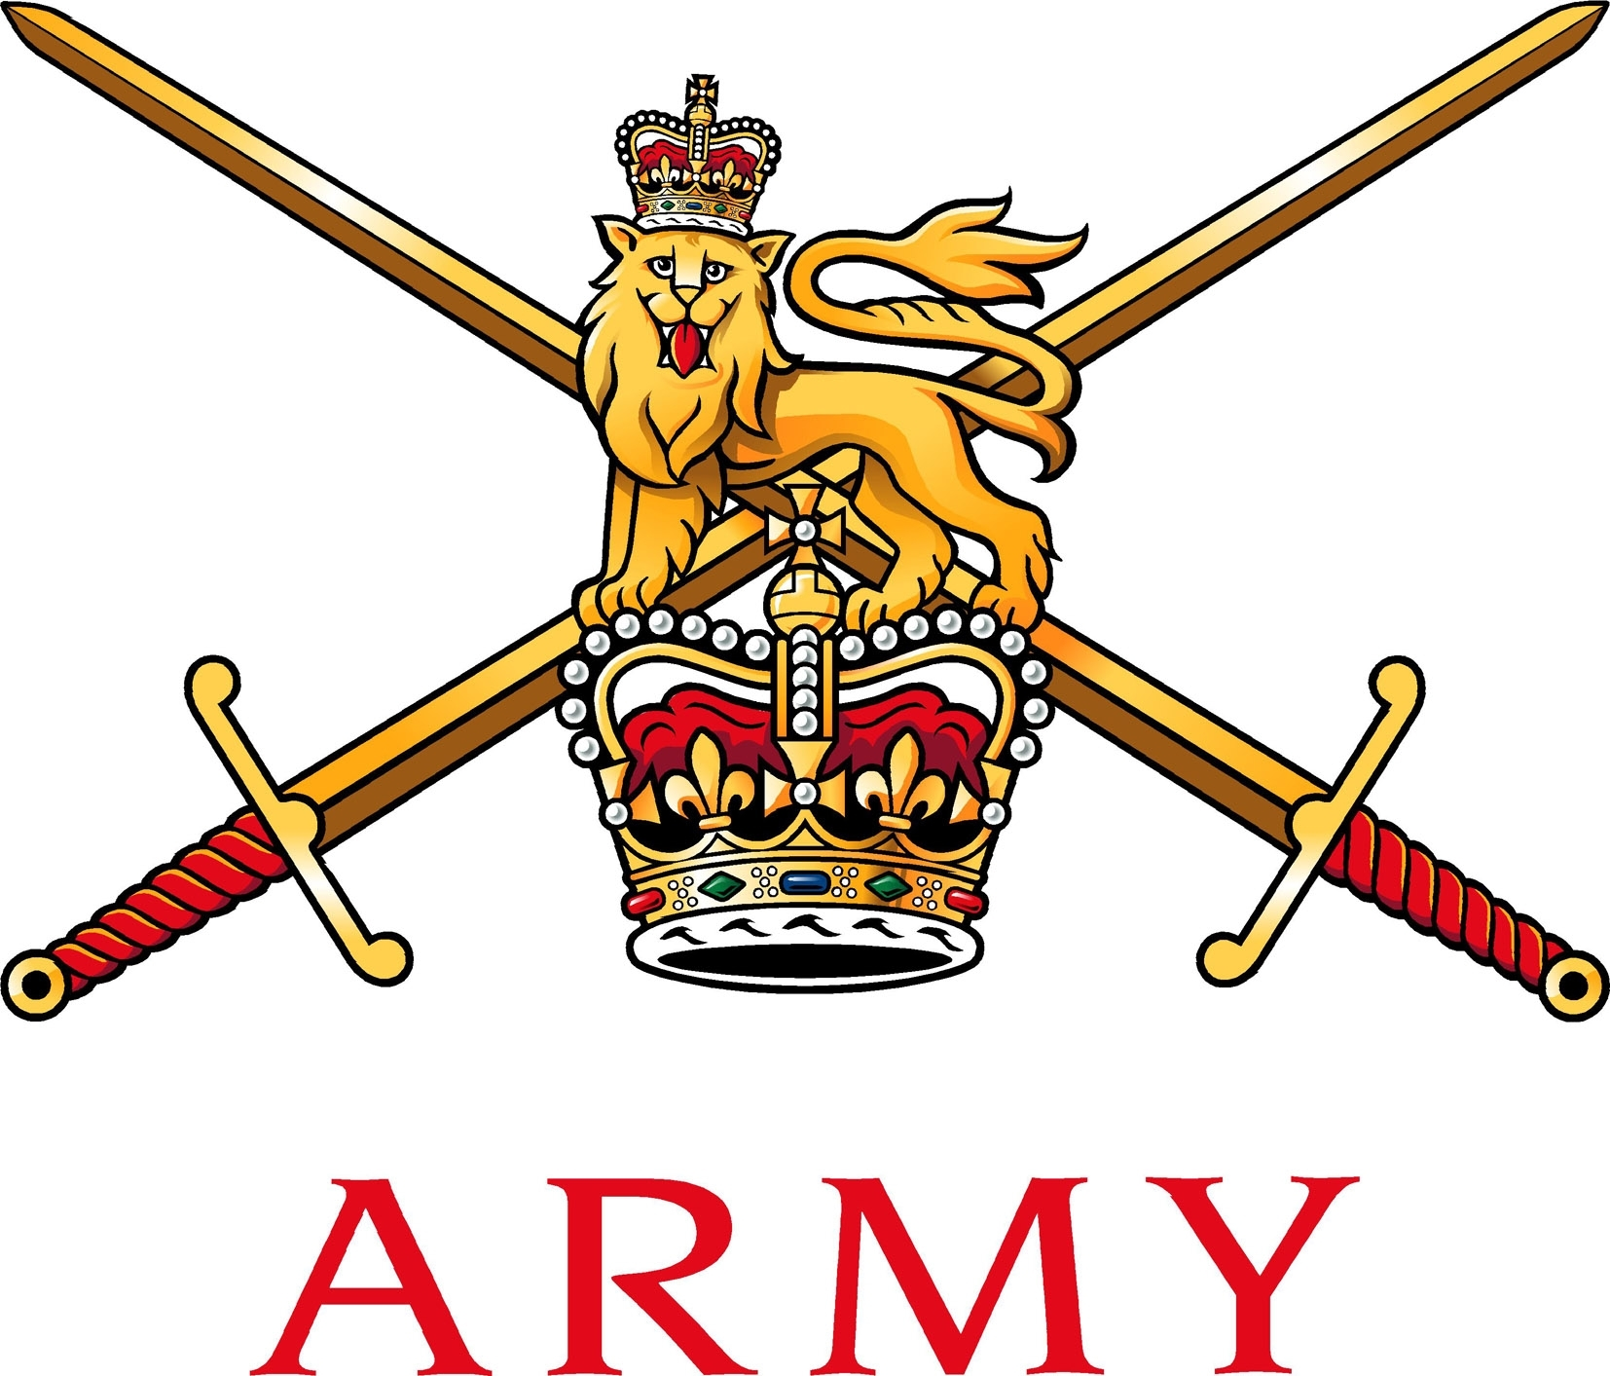

Col Stefan B Crossfield
Director Ice Sports
Mobile: 07952 947772
Army Winter Sports Association
Army Sports Control Board
MacKenzie Building, Fox Lines
Queens Avenue
Aldershot GU 11 2 LG
Email:DirectorIcesports@awsa.org.uk
T+44(0)1252 78 7078 Mil 94222 7078
F+44(0)1252 78 7079 Mil 94222 7079

15/10/2019

ARMY ICE SPORTS SAFETY PLAN 2019/2020

1. The Army Bobsleigh, Skeleton and Luge season will commence from the 1 December 2019 - 2 March 2020. The season includes the two novice weeks, the Army Championships and pre-Inter Services Training week. This safety plan contains guidance to safety officials, team managers and coaches as to safety procedures to be implemented during single service training and inter service training and competition.

Athlete Safety Briefing

2. All athletes are to be given a comprehensive safety briefing prior to the 1st day of sliding, regardless of previous experience and ability. All novice sliders are to be briefed on the exercise objectives regarding their progression and competency during the novice week daily. The brief is to contain the following points and any others considered pertinent to the days sliding.
All staff/athletes are to be aware of the standing operating procedures (SOPS) paragraph (9)

a. Starting Procedures.

- Procedures to be used at the finish.

- Actions to be taken in the event of a crash.

- Any pertinent points from the Risk Assessment.

- Risk Management

- Training Objectives (Ex Racing Ice One Novice Weeks)

- Location of medical Personnel.

3.All athletes are to carry out a track walk daily prior to the beginning of sliding. The 1st track walk in any training/competition week must be conducted and/or supervised by a coach or safety official. After this, athletes may carry out their own track walk but a coach is to be on hand to provide advice or guidance if required. This requirement may be waived if required by competition rules.

Duty Senior Safety Official

4.A Duty Senior Safety Official (DSSO) is to be nominated daily by the OIC. The duties of the DSSO include:

a. Delivery of a pre-sliding brief prior to daily sliding. The brief should include nomination of those responsible for First Aid, forecast weather conditions, radio frequencies to be used, actions in the event of an emergency/accident and whereabouts of athletes’ passports, EHICs and Insurance Documents

b. Co-ordination of other safety officials and coaches including a pre-sliding brief where appropriate. The DSSO is to remain in constant contact with other safety officials and the track manager through radio communication and/or the Track Intercom System.

c. Co-ordination of an emergency response in the event of injury or serious accident.

d. Provision of assistance to athletes following an accident. This is to include provision of relevant documentation to medical facilities, co-ordination with the insurance company and informing the athlete’s home unit or the compassionate cell where appropriate.

e. The DSSO may delegate their duties to a deputy whilst participating in sliding. However, a full handover brief must be conducted prior to the next sliding session and the deputy must not be participating in the session as an athlete or coach themselves. A sliding session is not to commence until the DSSO or nominated deputy gives the go ahead after consultation with the single sport coaches and/or team managers as appropriate.

Safety Officials

5. Safety officials for each session are to be nominated prior to the commencement of sliding each day and are to participate in the daily sliding brief. They are to ensure contact with the DSSO or nominated deputy is maintained at all times along with the medical support team

6. The minimum of three safety officials (including the DSSO) and two qualified medical personnel are to be positioned at the track at all times whilst sliding is underway. In the event of an accident or other event necessitating the DSSO or safety officials departing the vicinity of the track, sliding is can commence with one DSSO and one medical personnel until all three nominated safety officials are back on duty.

7. During Inter-Service training or competition, it is acceptable for personnel from other services/CSWSA to act as the nominated safety officials provided they are suitably briefed.

8. Terms of Reference (TORs) and a copy of the safety plan are to be provided and signed for by the DSSO, nominated deputy and safety officials prior to duties being carried out. They are also to review and sign as having read the Risk Assessment and Medical Risk Assessment relevant to the training/championships.

Standing Operating Procedures (SOPS)

9. Standing operating procedures are to be adhered to before commencement of the days sliding.

a. Start List for all participating athletes for each discipline to be handed to finish house, track office, prior to sliding. Starting order, running list explained to athletes, before sliding.

b. Medical Staff to be in location before commencement of sliding and radio communications established and checked.

c. Staff are to ensure that novice sliders fully understand the coaching and technical information that has been given before their first slide. This is to include operating the sled and steering, actions on accidents and where to depart track if accident occurs.

d. All Bobsleigh, Luge and Skeleton sleds are to be checked for serviceability daily prior to sliding. (Staff and students/athletes)

e. All Helmets, gloves and safety equipment is to be checked for correct fitting and serviceability before descending the ice track.

f. All students/athletes briefed on stopping procedures at finish area and correct procedure for leaving the track.

g. All students/athletes brief on moving equipment on camion/truck to relevant start area.

h. All Students/athletes debriefed on slide and given feedback, all participants checked for possible injures, after each slide.

i. All Students/athletes debriefed at the end of their days sliding and updated on their progression from the days sliding. All staff our to gain feedback from students/athletes

WO2 GR Holmes
Army Luge Secretary

Annexes:

A. Risk Assessment 2018/19 Season.
B. Athlete agreement form.
C. Report Form MOD 510.
D. Medical Risk Assessment 2018/19

