
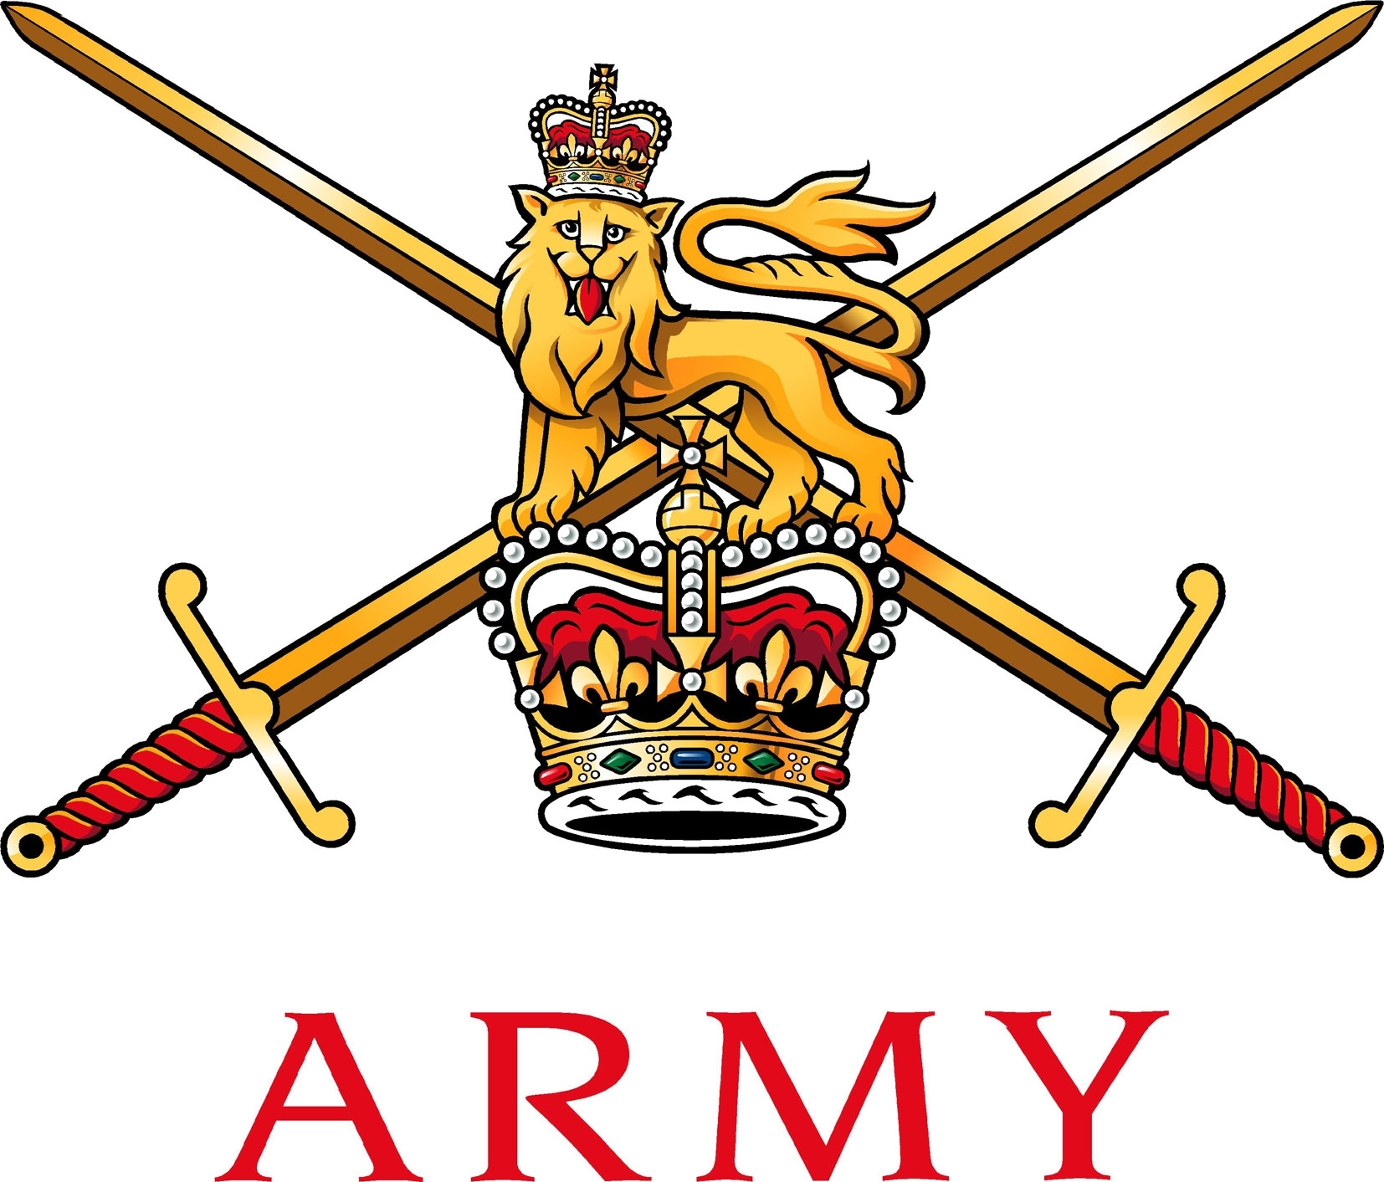

EXERCISE RACING ICE – MEDICAL INSTRUCTION

References:

A. 2018DIN07-077: Army European Winter Activity Instruction 2018/19
B. 2008DIN06-015 - The Reporting of Accidents and Incidents.
C. JSP 539 - Climatic injuries in the Armed Forces- Prevention and Treatment.
D. JSP 419 - Adventurous Training in the UK Armed Forces.
E. AGAI Volume 1- Adventurous Training
F. JSP 375 MOD Health and Safety Handbook
G. JSP 751, Volume 2
H. JSP 950 Medical Policy
I. AP3394 - RAF Aeromedical Evacuation Service
J. Commanders Guide to Climatic Injury.
K. ACSO 3216 – The Army’s Safety and Environmental Management System
J. The Defence Logistics Support Chain Manual Volume 6 Part 6.

INTRODUCTION

1. The Army Bobsleigh, Skeleton and Luge season known as Ex RACING ICE will commence from the 1 Dec 2019- 14 Mar 2020. The season includes a Novice Camp, the Army Championships and pre-Inter Services training week in accordance with Ref A. It is predicted that there will be ~ 100 competitors and staff within the military PAR. As stated in Ref A no competitor will be permitted to compete without providing medical insurance to cover the inclusive dates. This Medical Instruction contains guidance to the management of sickness and injury caused by any AT, sporting and competitive events (inclusive of ‘off-duty’ activity).

SPECIFIC ADMINISTRATIVE REQUIREMENTS

2. MES. All participants are to have a MES of MFD. If below this standard, a comprehensive risk assessment (Appendix 26) must be completed. No individual is to deploy with a Med Cat below MLD.

3. Athlete Safety Briefing. All athletes are to be given a comprehensive safety briefing prior to the 1st day of sliding, regardless of previous experience and ability. In addition, all athletes are to carry out a track walk daily prior to the beginning of sliding. The 1st track walk in any training/competition week must be conducted and/or supervised by a coach or safety official. After this, athletes may carry out their own track walk, but a coach is to be on hand to provide advice or guidance if required.

4. Duty Senior Safety Official. A Duty Senior Safety Official (DSSO) is to be nominated daily by the OIC.

5. MEDICAL

a. Safety Officials. Safety officials for each session are to be nominated prior to the commencement of sliding each day and are to participate in the daily sliding brief. They are to ensure contact with the DSSO or nominated deputy is always maintained along with the medical support team.

b. Medical Personnel. A minimum of three safety officials (including the DSSO) and two qualified medical personnel are always to be positioned at the track whilst sliding is underway. In the event of an accident or other event necessitating the DSSO or safety officials departing the vicinity of the track, sliding is not to recommence until at least three nominated safety officials are back on duty. The medical personnel are responsible for the provision of routine and emergency medical cover to athletes, staff and military visitors as required during the event. This will include, but is not limited to, the provision of emergency medical treatment and triage during and after on-ice training.
c. Trackside. A First Aid Post will be located at the most suitable location at the trackside. A recce of this location will be completed prior to training considering access points, safety and complexity of the track. A medic will always man this facility and provide emergency first aid trackside during sliding.
d. Routine Medical Cover. The medic will provide routine healthcare cover covering all minor and major injuries caused during training. Medical cover for minor injuries may be limited during sliding or in an event of a major incident. The provision of medical supplies is limited and there is no planned resupply.

e. Management of Concussion/ Mild Traumatic Brain Injury. In accordance Ref H JSP 950 Lft 2-4-3 provides guidance to medical personnel and commanders on the diagnosis and management of UK personnel presenting with concussion/ mild traumatic brain injury (TBI). Patients with concussion and TBI, can present with a variety of symptoms which normally manifest immediately following an event whilst most resolve quickly within minutes to hours, some may persist longer. Early identification, support and treatment of concussion/ TBI is important, further guidance can be found in annex G.

f. Prescription Medication. There are several private doctors and pharmacies in all the training locations throughout Ex RACING ICE however; it is advised that all participants bring an ample supply of routine medications for the duration of the exercise. Re-supply of medication cannot be guaranteed and should not be expected.

g. Reciprocal Medical Cover. Reciprocal emergency medical cover agreements exist between UK and over 40 countries, in addition to members of the EC. All participants and staff must possess a European Health Insurance Card (EHIC), which will be required for routine treatment and emergencies. It must be noted, however, that these types of reciprocal arrangements do not necessarily cover all expenses involved in medical treatment, and that these costs can be extremely high. It is therefore, mandated that personnel obtain individual Ice Sports insurance to meet any hospital or related expenses that may arise.

h. Dental. All personnel are to be dentally fit prior to deployment.

i. Spectacles and Corrective Lenses. Those personnel who require spectacles or contact lenses are to ensure that they have with them. For those using disposable contact lenses, daily disposables, rather than monthly disposables should be used. It is recommended that 30-day continuous wear lenses are not relied upon for the duration of the exercise.

j. Hearing Protection. Not required.

k. Cold Injuries. Specific direction regarding the prevention and management of cold injuries can be found in JSP 539. Planning at every level should consider the risks associated with Cold injuries. Risk assessments for each activity should include what mitigation is in place to protect personnel. Accurate weather forecasts should be obtained daily via the Meteorological Office. All cases where individuals develop temporary or permanent incapacitation i.e. are unable to continue with their duties/training because of climatic illness/injury with or without the involvement of Defence Medical Services or other medical assets, must be reported to the following:

i. Inform by telephone 24 hr Duty Officer – Defence Accident Investigation Branch (DAIB) - Mil 96798 Ext 6588 or 6587 / Civ (+44) 030 67986587.

ii. Complete Army Form 510 (electronic), in accordance with Army Command Standing Order 3216 and forward to the Army Incident Notification Cell (AINC) – Mil: 96770 3661 / Civ (+44) 03067 703661, MOD email: ASCen-AINC-Mailbox@mod.go.uk

6. COORDINATING INSTRUCTIONS

a. Timings.

Pers  (a) | Depart UK  (b) | Arrive in location  (c) | Depart  (d) | Comment  (e)
Ex RACING ICE 1 2019, Igls, Innsbruck, Austria
Exercise Staff | 29 Nov 19 | 30 Dec 19 | 14 Dec 19 | Ensure all kit and equipment is taken
Students (1) | 01 Dec 19 | 01 Dec 19 | 7 Dec 19 | Slide from 02/12 to 06/12
Students (2) | 08 Dec 19 | 08 Dec 19 | 14 Dec 19 | Slide from 09/12 to 13/12
Ex RACING ICE 2 2020, Army Ice Sports Championships’, Winterberg Germany
Exercise Staff | 10 Jan 20 | 11 Jan 20 | 18 Jan 20 | Bobsleigh, 12 – 16 Jan 20.  Luge and Skeleton, 13 – 16 Jan 20  Race Day: Fri 17 Jan 20.
Army Competitors | 11 Jan 20 | 11 Jan 20 | 18 Jan 20
EX RACING ICE 3 2019, Interservices, Königssee, Germany
All Staff and Competitors | 29 Feb 20 | 01 Mar 20 | 14 Mar 20
Army Competitors |  |  |  | Army Training will slide from 18/02/2019 to 22/03/2019
Inter-services |  |  |  | Inter-service sliding will be from 09/12/20 to 13/03/20

b. Location of Medical Services.

Ser  (a) | Service  (b) | Address  (c) | Contact number  (d) | Comment  (e)
Emergency Medical Locations
Igls, Innsbruck, Austria
1 | Emergency Services  Tryol Air Ambulance 24 hr | TAA Head Office  Fürstenweg 180  6026 Innsbruck, Austria | Tel: +43 512 224 22 100  www.taa.at | Used by Innsbruck bobsleigh Track for medical emergencies
2 | Unfallambulanz  Trauma Hospital 24hrs | Schöpfstraße 26, 6020 Innsbruck, Austria | - Tel: +43 512 50422825 | Public Hospital, specialising in trauma
3 | Das Allgemeine öffentliche Landeskrankenhaus  Innsbruck-University Hospital | Anichstraße 35, 6020 Innsbruck, Austria | - Tel: +43 050 504-0
4 | Physiotherapy | Heiligwasserwiese 8, 6080 Innsbruck-Igls, Austria | - Tel: +43 512 378510
5 | Pharmacy | Igler Str. 56, 6080 Innsbruck, Austria | - Tel: +43 512 377117
  Opening times Mon- Frid- 8am–12:30pm, 2:30–6pm
  Sat- 8am-12.00pm
Emergency Medical Locations
Winterberg Germany
6 | St Francis Hospital Profit 24 hrs | Franziskusstrabe 2-4 59955, Winterberg , Germany | - Tel: +4929818020 | 24Hrs
7 | Franziskus – Apotheke  Pharmacy | Poststrabe 6, 59955 Winterberg, Germany | - Tel: +49 2981 2521 | Opening Times Mon- Sat 8am- 7pm
Emergency Medical Locations
Königssee, Germany
8 | Schön Klinik Berchtesgadener Land | Malterhöh 1, 83471 Schönau am Königssee, Germany | Tel: ++49 8652 930 | General Hospital
9 | Grünstein - Apotheke | Artenreitring 1A, 83471 Schönau am Königssee, Germany | Tel: +49 8652 96390 | Pharmacy
10 | Krankenhaus Berchtesgaden GmbH | Locksteinstraße 16, 83471 Berchtesgaden, Germany | Tel: +49 8651 772280 | Hospital

c. Routine Sick Parade. The Ex Medic will be available to take routine sick parade from 0700 from the First Aid Post until 1730 each day of the exercise. Participants can be reviewed outside of these hours by calling the medic directly (tel: 07703989991). Primary Health Care facilities are available in all exercise locations if required. Locations detailed above.

d. Feeding. All personnel undertaking training are to parade daily for breakfast. Lunches should be taken or can be purchased at participants own expense for the duration of ‘on-duty’ activities.

e. Water. Participants are to bring a serviceable water bottle/ flask to training to ensure they keep hydrated. Many opportunities will be made throughout training to purchase other drinks throughout training.

f. Hand Washing. All personnel are to wash their hands/use alcohol gel prior to eating.

g. Emergency Procedures. All emergencies are to be notified through the duty medic and the DSSO, once an initial assessment has been completed. Emergency evacuation of a major incident must be via the host nation emergency services. The emergency services are to be contacted using the designated emergency number 112 (which is the same in both countries). In the unlikely event that personnel become separated, the exercise DSSO must be notified immediately. All personnel must always carry an in date EHIC, Passport and a copy of their insurance. The EHIC enables access to healthcare for free, or at a reduced cost; however, the host nation ambulance services are not free of charge, so it must be fully considered in an emergency whether the person requires an ambulance, or whether they are fit enough to be transported to the hospital via alternate means. For all non-urgent evacuations, it is the responsibility of the team captains or medic (if available) to aid transport.

h. Major Medical Incidents. A major medical incident is defined as a situation where the location, number, severity or type of live casualties, requires extraordinary resources. It is not triggered by a certain number of casualties. Actions on a major medical incident are as follows:

i. STOP all activity.

ii. Check the scene is safe to enter.

iii. The duty medic will assume control and is the conduit of information until
they are relieved by higher authority.

i. Army Incident Notification Cell (AINC). The expedition medic or DSSO must also inform AINC of the incident in accordance with Annex h of ASCO 3216 and submit Army Form 510 (accident report form) as soon as practically possible to AINC. Contact details as follows:

i. Tel Mil - 96770 3661 (Office hours)

ii. Tel Civ - (+44) 03067 703661 ( Office hours)

iii. Fax Mil - 94393 6889 Fax Civ - 01264 886889

iv. Email Mil - ASCen-AINC-Mailbox@mod.go.uk

j. Incident Reporting. In addition to the NOTICAS and casualty reporting procedures, DSSO Exercise is required to complete a Land Incident Report (INCREP) for any incident or accident (including near misses) if the following circumstances are applicable:

i. The incident may arouse public interest or criticism.

ii. Ministers and senior officers must be informed of the incident.

iii. The incident has a criminal, disciplinary or security aspect to it.

iv. The incident results in death or serious injury.

v. The incident may involve media enquiries.

k. MEDICAL EVACUATION. It is essential that the following generic information is provided, when requesting MEDEVAC:

i. Type of incident (what has happened).

ii. Number of casualties and severity.

iii. Location of casualties - Grid references are to be provided, where possible.

iv. The POC, or phone number of the individual submitting the report. Note: These means of communication must remain manned throughout the incident.

l. Ground MEDEVAC. For all minor incidents that cannot be treated at the point of injury and require further medical attention and/ or diagnostic intervention the duty medic at the training area will escort the patient to the nearest suitable medical facility for further assessment and treatment. In all major incidents host nation evacuation vehicles must be used.

m. Strategic MEDEVAC. In accordance with Ref I Strategic Evacuation of MOD personnel to the UK is to be coordinated through the Aeromedical Evacuation Control Centre (AECC) at RAF Brize Norton. Units returning personnel to the UK for medical reasons are to use the Patient Movement Request (PMR) formats 1 and 2 detailed in annex D. Prior to the submission of PMR 1 and 2 the AECC duty controller is to be contacted iot to raise an alert and for further support.

n. Marking of EHLS. In the event an EHLS is required, it must be easily identifiable and as detailed by the Track Officials.

o. Casualty Evacuation Plan. The below schematic details the CEP.

Immediate Actions co-ord through AT training Staff
Casualty occurs
Provide First Aid
Report to Emergency services:
a. Type of Incident
b. Number of Casualties
c. Location of Casualties
d. POC details and individual contact details
Task Medic
Medic asset returns to readiness location
Casualty Assessed
URGENT
Via ERV
Air Ambulance
Gd Ambulance
Dial 112
Medic asset on scene
HLS established
Mark HLS as directed
Medic moves casualty to HLS
Handover of casualty from Medic to civilian medical services
Cas moved to hospital by civilian ambulance service
From POI
Inform OC AT package
Inform OC AT package
Inform OC AT package
Report to OC AT package
a. Type of Incident
b. Number of Casualties
c. Location of Casualties
d. POC details and individual contact details
Task Medic
Fit to Train
Not Fit to Train
MEDEVACed to DPHC Talbot Bks, or Civ Hospital
Casualty Assessed
Fit to continue training
Not fit to continue training
Arrange further treatment or RTU
SQMS to arrange tpt back to Trg Area
NON-URGENT
Actions/Decisions at the scene/unit
Actions/Decisions by OC AT
Actions/Decisions by the civilian ambulance services
Actions/Decisions by the medical RLS personnel
Medic moves casualty to ERV

7. SERVICE SUPPORT

a. Logistic Support. In order to support the health and safety of all participants during Ex RACING ICE the organising committee will have the following available.

b. Vehicles. The use of vehicles is required to aid transportation and assist in the ground MEDEVAC of participants throughout Ex RACING ICE. The medical staff will have a 4 x 4 vehicle allocated to them for the duration of sliding. The vehicles are to be safety checked and prepared for winter conditions prior to deployment. It is the responsibility of the drivers to ensure that the vehicle is fully serviceable before leaving the UK. All faults should be reported immediately.

c. Radios. All members of the organising committee and coaches will be supplied radios throughout the duration of training and competitions. The use of radios is essential in delivering vital information in a fast and efficient manner to all ensuring the health and safety of all participants. In the event that signal is limited to the radios, track phones are located at the start and finish house, the medical room and along the track at frequent intervals along the track. Track phones can be utilised by anyone to send vital information ensuring training is safe at all times.

d. CCTV. Increasing the safety of participants throughout Ex RACING ICE is crucial. There are cameras located along the track recording each individual slide. The track manager always monitors this in the finishing house during sliding. As a result, all incidents are highlighted immediately, improving the response time of medical care to the point of impact. Emergency services can also be contacted by the track manager on visualisation of an incident if required.

e. Medical Supply and Resupply. The Ex Medic will supply all medical supplies trackside, however there is no planned resupply.

COMMAND AND SIGNALS

8. Communications Methods. The following are the communication methods to be used – in order of priority – to request medical support:

a. Track Phones.

b. Radios.

c. Civilian emergency services:112.

9. Requesting Aeromedical Evacuation. The AECC coordinates all global Strategic Aeromedical missions for all Military personnel whether on Ops or Exercises. They conduct a clinical reisk assessment to ensure that the most appropriate aircraft, medical teams and equipment are tasked to retrieve a patient AECC Contact details:

a. Routine Contact (0900-1700 hrs) + 441993 895300/ +441993 842551

b. Out of hours (1700- 0800hrs) +447770648688

c. Email: - Air38Gp-TMWAECC@mod.gov.uk

Original signed on file Original signed on file

Annexes:

A. Medical Centres Opening Times, Contact Numbers and Miscellany.
B. Accident & Notification of Casualty Reporting Procedures.
C. Army Form 510.
D. PMR 1
E. PMR 2
F. Athlete’s Declaration
G. Concussion/ mTBI Management
H. Commanders Guide to Concussion

Annex A To
Ex RI Med Ins
Dated 28 Oct 19

MEDICAL CENTRES OPENING TIMES, CONTACT NUMBERS AND MISCELLANY
1. General. Military personnel not based in BFG, their eligible civilian support (MOD employees) and other entitled personnel can expect to receive a standard of health care broadly similar to that of the NHS in the UK.
2. Sick parades. BFG no longer operates soldier’s sick parades. If personnel are feeling unwell, they must first contact the duty medic, alternatively they can call TAS (0049 (0) 521305 3961). Medical Centre locations and telephone numbers are detailed here:http://www.patient-wise.de (the medical information hub for BFG personnel). It is important to note that these medical facilities are a minimum of 5 hours drive away from the training locations throughout the duration of Ex RACING ICE.
3. In the event of a medical emergency. If you believe your condition to be serious, or a medical emergency, you should go directly to the Accident and Emergency Department at the local hospital. The Ambulance Service can be contacted by dialling 112.
4. Where possible. Once the ambulance service has been called, a second call should be made to the Hospital Hotline Number, 0800 588 9936. The patient support officer will then, in turn, inform the medical centre to which you are registered (if applicable).
ENHANCED SUPPORT SERVICES FOR PATIENT IN HOSPITAL

5. BFG patients needing care in non-contracted hospitals benefit from extended patient support services. The Hospital Hotline improves ‘first-line’ support given to entitled personnel attending A&E or admitted as in-patients to hospitals within BFG and where possible, EJSU locations.
- The service is provided by our Patient Support Officers (PSOs) whose role is to assist BFG patients with language problems. They are also familiar with procedures and practices within German hospitals and can help patients overcome any concerns and make their stay as comfortable as possible.
- The PSO will also obtain consent from the patient for the release of information to the medical/dental centre, Unit and as appropriate to the welfare services. This will ensure that translation of discharge documents, follow up appointments at the medical/centre or hospital, payment of the hospital bill, NOTICAS and other administrative procedures are initiated quickly by the relevant agencies.
- The Hospital Hotline number to call is 0800 588 99 36 and where possible should be rung prior to any admission to the hospital (except in emergency cases where a call to emergency services on 112is the default). The service is available 24 hrs/7 days a week/365 days a year via telephone. The Hospital Hotline is free for calls made from a landline. Calls made from a mobile phone may be charged.
- Most patients needing hospital care in BFG, are usually referred or admitted to one of four contracted Designated German Provider hospitals (AKH Viersen, EvKB Gilead in Bielefeld, St Vincenz Krankenhaus in Paderborn, and Henriettenstiftung in Hannover). However, these hospitals are located too far away to use during Ex RACING ICE therefore it is accepted in these circumstances that a non-contracted hospital will need to be used.

Annex B To
Ex RI Med Inst
Dated 28 Oct 19

Accident & Notification of Casualty Reporting Procedures

- Notification of Accident Procedures. All accidents, incidents, near misses, dangerous occurrences and equipment failures121 across the Army TLB must be reported to the Army Incident Notification Cell (AINC) using the Army Form 510 (it can also be downloaded from the ASCen intranet page on MODnet). The form must contain as much detail as possible and include any equipment being used at the time with, where appropriate, exercise instructions and supporting documents attached. The form is not to be amended in any way. Once completed, forms are to be sent to the AINC group mailbox.

- What is the Army Incident Notification Cell (AINC)? The AINC is the focal point for the notification and data collation of all Army incidents, accidents, near misses, occupational ill health, serious equipment failures and dangerous occurrences including those involving fire, world-wide. AINC maintains the Army’s Incident Notification System (INS); the repository for all incident reporting (AF510) and subsequent documentation132. It supports ASCen in carrying out its reporting requirements on behalf of the Army to the Defence Safety Authority (DSA) and UK statutory authorities, including the Health and Safety Executive (HSE) and the Environment Agency (EA).

- What should be reported to AINC? Accidents and incidents involving the following are to be notified to AINC:

- Injuries to personnel:

    - Military Personnel. Injuries including climatic and sporting injuries and injuries as a result of both on and off duty road traffic accidents (RTAs).
    - Civilian Personnel. Injuries including injuries as a result of on and off duty RTAs.
    - Contractors and Non-MOD Civilians. Injuries occurring on MOD property or as the result of Army activities.
- Where can I find out about AINC? The details of AINC are contained in ACSO 3216 Ref h.

- How does AINC benefit units and individuals? AINC operates on the ‘call centre’ principle and acts as a ‘clearing house’ for processing information relating to accidents and incidents across the Army. It provides a single point of contact for reporting incidents world-wide, ensuring that units carry out, or are guided through, the necessary notification and reporting procedures in accordance with Service Instructions.

- What are the thresholds for reporting to AINC? Injuries requiring professional medical treatment at either an MRS, a doctors’ surgery or an A&E Department. All other injuries resulting in 3 days off work, or in the case of military personnel, 3 days light duties. Serious pollution incidents should also be reported and all near misses.

- What Information do I need to provide if reporting an accident or incident?

- Name and contact number of the person reporting the incident.

- Details of people involved.

- Unit and/or UIN.

- Where.

- When.

- What happened?

- When and how do I notify AINC? If serious, notification should take place as soon as possible, having regard to the information requirements above. Otherwise notify the AINC during working hours.

a Mil Email: ASCen-AINC-Mailbox@mod.go.uk

b. Telephone. Mil: 96770 3661 or Civil: 03067 703661 (Office Hours).

c. Fax. Mil: 94393 6889 or Civil: 01264 886889

- Who can report to AINC? Anyone in the Army - or working for the Army. It is preferable however that it should be done through the unit safety focal points who should keep copies of the Accident Report form (MoD Form 510). If the incident reported is below the AINC threshold, the unit should nevertheless make an accident book entry on a local BI 510 or MOD Form 510.

- Can I report an accident or near-miss to AINC without giving my name? No. Action cannot be taken on an anonymous 'tip-off'. However, you could ask to speak to the OIC of AINC and discuss as much of the incident as you are comfortable with. The situation has probably arisen before and an answer can be found. If however you have suggestions which could help prevent harm to others, please use our online form, which can be submitted anonymously.

- A civilian is injured, does it still have to be reported to AINC? Yes - provided that:

- The injury was as a result of the actions of the Army.

- He or she was on MOD land.

- He or she was under contract to the Army.

- An accident happened two months ago, can it still be reported? Yes.

13. In addition to reporting incidents to AINC, all deaths, serious injuries or significant losses of equipment capability are to be reported to DAIB. The POCs for reporting are as follows:

a. Land domain: 03067 986587 – (manned 24/7). Follow-up email to: DSA-DAIB LandMailbox (MULTIUSER).

b. Maritime and Air domains: 03067 988276 – (manned 24/7). Follow-up email to: DSADAIB-Air-Mailbox (MULTIUSER).

14. Notification of Casualty (NOTICAS). In the event of casualties occurring the Joint Casualty and Compassionate Centre (JCCC) may need to be informed. More details of Casualty Notification are laid down in JSP 751 which the Sqn must deploy with. In general, there are 2 methods of reporting to the JCCC which are as follows:

- The preferred method is by completing the casualty reporting section on the JPA
system.

- Where JPA is not available or offline, the Sqn is to send a “NOTICAS” by immediate signal or fax. Because of the possible delays in communication, wherever possible the Sqn should also alert the JCCC by telephone that a NOTICAS message is being sent. If the Sqn is unable to contact the Emergency Contact (EC) of the casualty the JCCC will select and warn the likely Notifying Authority; however, no contact is to be made with the EC until the NOTICAS message has been received by JCCC. Alternatively, for all casualty and compassionate cases JCCC can be contacted on (+44) 01452519951.

- Casualties to be Reported. The following casualties are to be reported:

- Deaths. For a death to be notified there must be no doubt whatever as to the fact. Whenever there is the slightest question whether death has occurred, e.g. where a service person is believed to have drowned, but the body has not been recovered and identified, the casualty must be notified as either ‘Missing – Believed Killed (MBK) or Missing Not Known (MNK)’. (Official presumption of death is not a notifiable casualty) See Annex A Chapter 2 of JSP 751.

- Very Serious Injuries (VSI). A patient is termed ‘very seriously ill’ when his/her illness or injury is of such severity that life is imminently endangered.

- Serious Injuries (SI). A patient is termed ‘seriously ill’ when his/her illness or injury is of such severity that there is cause for immediate concern, but there is no imminent danger to life.

- Incapacitating Illness & Injuries (III). This category applies to an individual whose illness or injury requires hospitalisation, whose condition does not warrant classification as VSI or SI.

- Unlisted Casualties (UL). An individual whose illness or injury requires hospitalisation but whose condition does not warrant classification as VSI, SI or III. Casualties who have been unexpectedly admitted to hospital and medically categorised as UL and are on operations, overseas deployment or exercise should be reported to JCCC.

- Admittance to Hospital. There is no requirement to report persons away from their home base who are temporarily attending, or admitted to, hospital for period of less than 72 hrs for minor medical conditions that, in the opinion of a medical officer, would have been treated at Role 1 and followed by a period of sick leave were the individual home-based. When admissions exceed 72 hours they are to be reported by NOTICAS with effect from the date and time of admission.

- Serious damage to equipment and incidents of serious equipment failure in accordance with the Defence Supply Chain Manual JSP 336 Volume 12 Part 2 Pamphlet 2.

- Illnesses, diseases and dangerous occurrences in accordance with RIDDOR reporting requirements under Regulation 15 Schedules 1, 2 and 3

Annex C To
Ex RI Med Inst
Dated 28 Oct 19

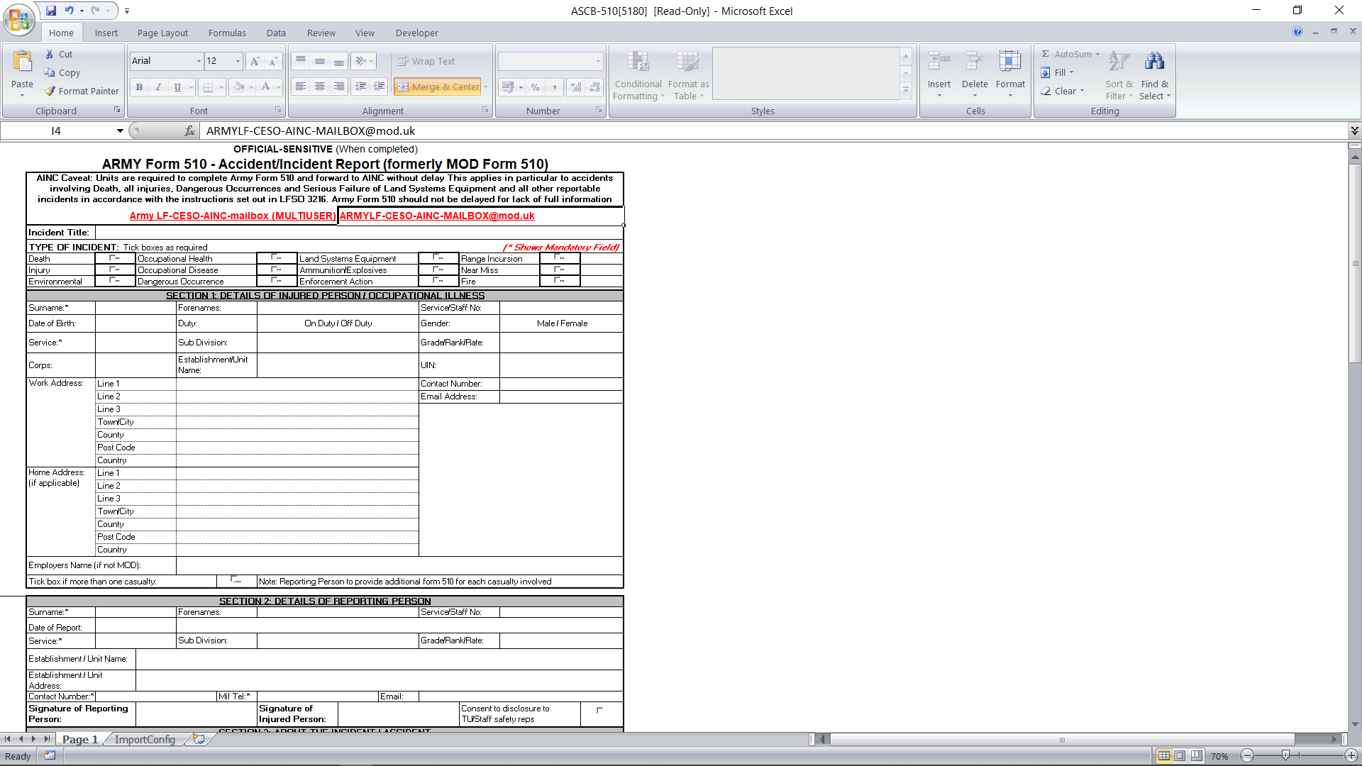
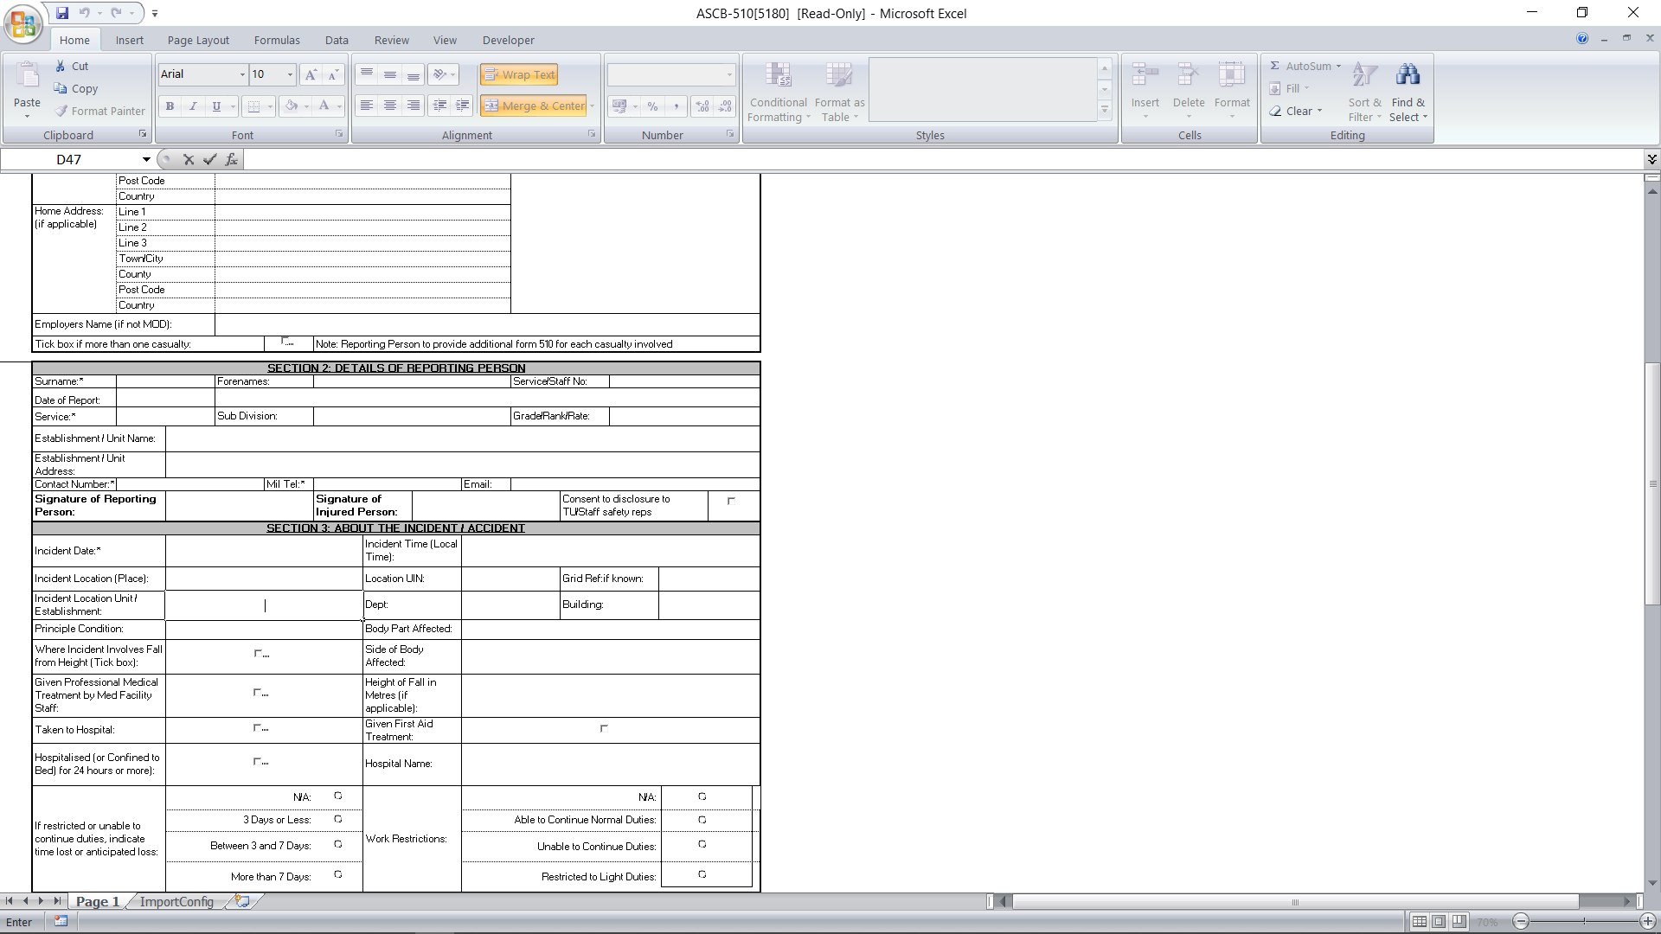

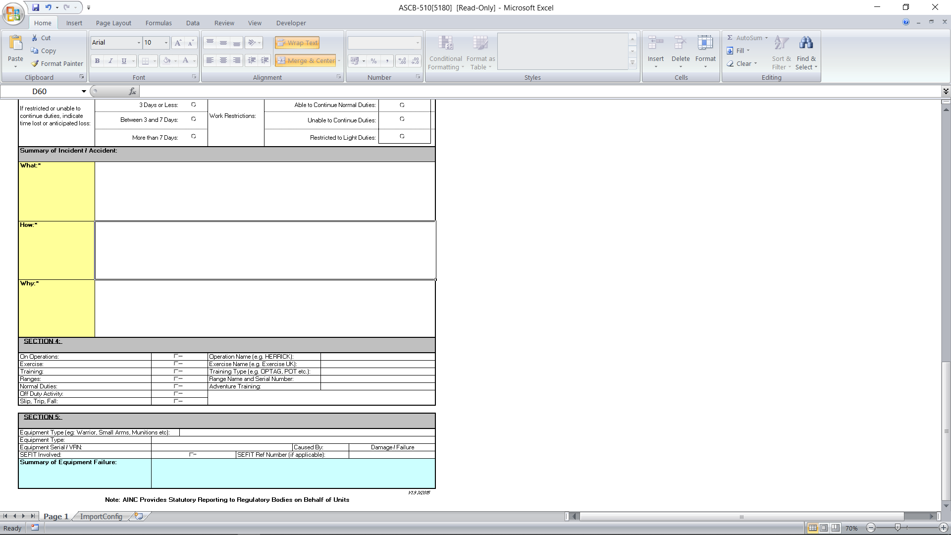
https://armysportcontrolboard.com/wp-content/uploads/2019/06/ACSO_3216.pdf

Annex D To
Ex RI Med Inst
Dated 28 Oct 19
OFFICIAL SENSITIVE PERSONAL
MEDICAL IN CONFIDENCE.

SUBJECT AEROMEDICAL EVACUATION

1 PMR 1 DTG: [insert DTG]

2 Request permission to emplane the following patient on [DATE, FLIGHT NUMBER] or [NEXT AVAILABLE FLIGHT] or [AS DESIGNATED BY AECC] [insert from and to locations].

PATIENT [ALPHA]

3 PRIORITY [1], [2] or [3]

4 [Service Number]. [Rank]. [Surname]. [Forename(s)]. [Date of Birth]

5 [Service and Unit (Theatre and UK)].

6 [Entitlement Category] [Passport details].

7 [Sitting] or [Stretcher]

8 [PRESENT LOCATION OF PATIENT], [CONTACT TELEPHONE NUMBER], [ADDRESS OF HOSPITAL] and [DETAILS OF MO IN CHARGE]

9 [CABIN ALTITUDE RESTRICTION]

10 [ACCOMPANYING RELATIVES]

11 [SPECIAL DIETARY REQUIREMENTS]

12 PATIENT DISPOSAL: (state whether patient requires [DIRECT ADMISSION] (for hospital admission and whether or not arranged),state hospital or [DISCHARGE AIRHEAD] ] For patients that require outpatient appointments or follow up by unit MO / DCMH (include details of all date / times of arranged out-patient and RRU appointments in PMR 2)

13 TRANSPORT ARRANGEMENTS: [PARENT UNIT] [PRIVATE] [AS DESIGNATED BY AECC]

14 PATIENT LISTING: either [UNLISTED (UL)], [INCAPACITATING ILLNESS OR INJURY (III)], [SERIOUSLY ILL (SI)] or [VERY SERIOUSLY ILL (VSI)].

15 [MES AND DATE AWARDED].

16 [BATTLE INJURY] or [NON-BATTLE INJURY] or [DISEASE]

17 PMR 1 Written By [ Rank, Forename, Surname] [Telephone Number]

OFFICIAL SENSITIVE PERSONAL
Annex E To
Ex RI Med Inst
Dated 28 Oct 19
MEDICAL IN CONFIDENCE.

1. PMR 2 DTG: [insert DTG]

2. SUBJECT AEROMEDICAL EVACUATION.

CONNECT WITH PMR 1 [insert DTG of PMR 1 from Annex A ].

PATIENT ALPHA

3 [CLASSIFICATION] and [DEPENDENCY]³

4 [DIAGNOSIS] (include diagnosis whether working or confirmed). [FULL CLINICAL DETAILS], [DATE OF ONSET], [CAUSE OF INJURY], [ANY OPERATIONS OR TREATMENT RECEIVED TO DATE]. [FULL DETAILS OF MEDICATIONS]. [FULL SET OF OBSERVATIONS INCLUDING OXYGEN SATURATIONS AND HB IF AVAILABLE].

5 CONSIDERATIONS FOR FLIGHT

A FULLY MOBILE [YES] or [NO]
B CAN PT CARRY OWN BAGS [YES] or [NO]
C CAN PT CLEAR EARS [YES] or [NO]
D DOES PT REQUIRE A WHEELCHAIR [YES] or [NO]

6 [INFECTION RISK ASSESSMENT:

A FEVER [YES] or [NO]
B DIARRHOEA [YES] or [NO]
C VOMITING [YES] or [NO]
D RASH [YES] or [NO]
E COUGH [YES] or [NO]
F INFECTION RISK [YES] or [NO]
G MRSA STATUS [UNKNOWN] or [MRSA POSITIVE] or [MRSA NEGATIVE]

7 [Details of arranged out-patient and RRU appointments] FOR FACILITIES WHOSE NAME CONTAINS INFORMATION WHICH CAN BE LINKED TO THE MEDICAL CONDITION, USE FACILITY LOCATION ONLY (Street, County, Postcode)

8 Medical Escorts Required:[NO ESCORTS REQUIRED] or [TO BE DETAILED BY AECC BRIZE NORTON] or [CCAST] or [PHYSICIAN] or [NAME RANK SERVICE NUMBER OF ESCORTS (IF KNOWN)]

9 PMR 2 Written By [Rank, Forename, Surname] [Telephone Number]

Annex F To
Ex RI Med Inst
Dated 28 Oct 19
ATHLETE’S DECLARATION

I, the undersigned, make the following declaration:

Last Name | First Name (s) | Service Number | Unit
Discipline*: 2-Man Bob / Luge / Skeleton |  |  | Gender*: Male/Female

*delete as applicable

1. EX RACING ICE 1 RULES, REGULATIONS AND PROCEDURES.

I understand and accept that my participation in Ex RACING ICE 1 is subject to my acceptance of all rules applicable and in connection with such event. I, therefore, agree to be submitted to such rules, regulations and procedures and to the jurisdiction of the organising committee of Ex RACING ICE 1 which is in charge of applying them.

2. ACKNOWLEDGEMENT OF RISKS.

I am fully aware and conscious of the potential risks involved in competing in ice sport activities and of the risk caused by speed and gravitational forces. I accept that the risk factors include environmental conditions and technical equipment. I am further aware that certain movements or actions cannot always be anticipated or controlled and therefore cannot be avoided or prevented through safety measures. Consequently, I know and accept that when I engage in such activities, my physical integrity and in extreme cases, even my life may be at risk. Furthermore, I know and accept that the above mentioned dangers linked with my participation may threaten third parties within the competition and training area. I will conduct my own inspection of training courses. I will immediately notify the Ex RACING ICE 1 officials of any safety concerns I may have. I understand that I am responsible for the choice of the appropriate equipment and of its condition, for the speed at which I slide and for the selection of my line through the course.

3. PERSONAL LIABILITY.

I understand that I may be found personally liable to third parties for damages arising from bodily injury or property damage they may suffer as a result of an occurrence linked with my participation in training. I agree that it is not the responsibility of Ex RACING ICE 1 staff to inspect or supervise my equipment.

4. RELEASE.

To the extent permitted by the applicable law, I release the AWSA, my National Association, and the organizers and their respective members, directors, officers, employees, volunteers, contractors and agents from any liability for any loss, injury, or damage suffered in relation to my participation in AWSA sanctioned training. This declaration shall also be binding on
my heirs, successors, beneficiaries, next of kin or assigns who might pursue any legal action in connection with the same.

5. UNIT CONTACT DETAILS.

Unit Address | UIN | Duty Officer Mobile No. | Adjt Name | Adjt Telephone No.

6. NEXT OF KIN.

In order to meet Diplomatic Clearance information requirements, I confirm that my JPA-nominated Next of Kin (NoK) details are as follows below:

Name | Relationship | Contact Details (phone number only)

7. EHIC DETAILS.

In the event of an emergency, it may be necessary to pass EHIC information to the local medical services to secure treatment for you. Please enter the details from your EHIC below:

3. Name | 4. Given Names | 5. Date of Birth | 6. Personal ID No. | 7. ID No. of the Institution | 8. ID No. of the card | 9. Expiry Date

8. ICE SPORTS INSURANCE.

In the event of an emergency, it may be necessary to pass ice sports insurance cover information to the local medical services to secure treatment for you. Please enter the details from your policy documentation below:

Name of the Policyholder | Name of Insurer | Policy No. | Emergency Medical Contact Telephone No.

9. ATHLETE’S DECLARATION.

I understand that all details will be held by the Ex RACING ICE 1 Comd and that they will be treated in confidence and used only in the event of an emergency for the provision of medical assistance or military casualty reporting. I have read and understood the above Athlete's Declaration.

Signature: _____________________________________

Annex G To
Ex RI Med Inst
Dated 28 Oct 19

CONCUSSION / MTBI CLINICAL MANAGEMENT ALGORITHM

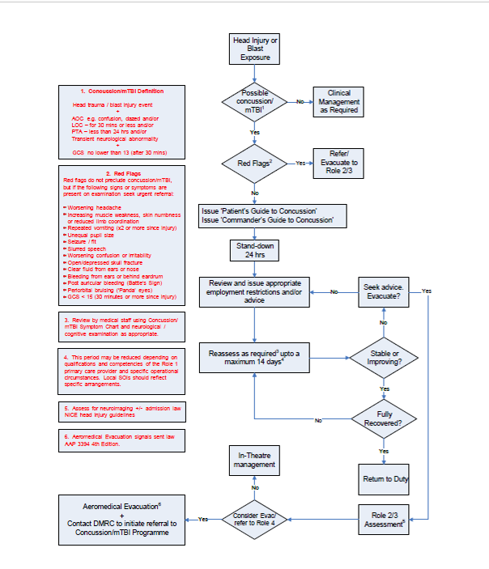
Annex H To
Ex RI Med Inst
Dated 28 Oct 19

COMMANDER’S GUIDE TO CONCUSSION

What Is a concussion? A concussion is a head injury from a hit, blow, or jolt to the head (either from a direct blow or from being close to a blast) that briefly knocks the person out (loss of consciousness), or makes them feel confused or “see stars” (alteration or change in consciousness).

What are the symptoms? Immediately or soon after the concussion, the affected individual may feel disorientated and may experience headaches, dizziness, balance difficulties, ringing in the ears, blurred
vision, nausea, vomiting, irritability, temporary gaps in memory, sleep problems, or attention and concentration problems.

How long does it last? Most people recover completely from a concussion. Individuals should be reassured that symptoms usually begin to improve within hours and typically resolve completely within days to weeks.
Recovery. Recovery is different for each person and depends on the nature of the injury. The most important thing is to allow time for the brain to recover and this is best done by a combination of rest and a graduated return to full duties.

Why does a concussion affect return to duty? Concussion can reduce effectiveness which could impair
an individual’s performance. In the operational environment this may endanger them or their colleagues. If the individual sustains another concussion before healing from the first one, they are at greater risk of a more serious injury.

How can I help? Evidence shows that you can assist the speed of recovery by reducing the demands placed upon the individual to a level that does not worsen their symptoms. Medical staff will advise on any ‘stand down’ or period of light duties/restricted activity but you are better placed to tailor this to the individual’s role. Match duties to the individual’s ability and level of symptoms. Encourage them to talk regularly with you about this. If symptoms get worse this may indicate they are pushing themselves too hard. Routine and familiar tasks will be easier than new and unfamiliar ones. Encourage personnel to take extra breaks if needed. Once symptoms have stabilised increase the amount of work gradually.

Do’s and Don’ts: Advice for Patients

Things that aid Recovery | Things that impair Recovery
 | - A further concussion before healing of the first one  - Alcohol  - Inadequate sleep (made worse by caffeine or  ‘ energy-enhancing’ products)  - Aspirin, ibuprofen, and other over-the-counter pain medications unless instructed by medical staff  - Sleeping medication unless instructed by MO
  - Maximise downtime/rest during the day
  - Get plenty of sleep
  - Protect from further concussion; no contact sports
  - Let colleagues know that they’ve had a concussion so they can look out for them – use ‘buddy’ system
  - Return immediately to medical staff if they are feeling worse or experience any warning signs*

Coping Measures. The following table lists some practical coping measures that patients are advised to use:

Symptom | Action
Slower Thinking, Confusion and Difficulty  Concentrating | - Establish a daily routine and structure their time.  - Ask others to slow down and to repeat things if needed.  - Allow extra time to complete tasks.  - Break activities down into smaller periods and take more rests.  - Do only one thing at a time.  - Avoid distractions e.g. turn off the TV/radio when working.  - Consult with friends/colleagues when making important decisions.
Memory problems
  - Put important items in the same place all the time.
  - Use a pen and notebook to keep track of things that need to be done or are hard to remember.
  - Ask friends and colleagues to remind them.
Irritability | - Walk away from situations if they cause annoyance.  - Actively use relaxation techniques.  - Working out in the gym can help if it does not over-tire.  - More rest can reduce irritability.
 | - Rest whenever possible
  Fatigue
Anxiety, sleep problems, and low mood | - These tend to be reactions to the other problems and tend to improve as other symptoms reduce. If affected personnel are worried about them see medical help.

Ensure Official Sensitive Personal Medical in Confidence is written at the top and bottom of each page
Multiple patients are to be sequentially indexed ALPHA, BRAVO, CHARLIE etc
Entitled],[Non-entitled],[entitled on a repayment basis] see Lflt 9-01 and Lflt 9-02).
If any; if none, state NONE
e.g. [NONE],[VEGETARIAN], [LIQUID], [SOFT], [DIABETIC], [LOW FAT] or [HALAL]
Must also state if patient is required [TO BE SEEN WITHIN 24 HOURS] or [NEXT WORKING DAY AFTER ARRIVAL AT UNIT BY OWN GP (SMO)].
See JSP 751.
Can be summarised to [BI], [NBI] or [D].
Ensure Official Sensitive Personal Medical in Confidence is written at the top and bottom of each page
Multiple patients are to be sequentially indexed ALPHA, BRAVO, CHARLIE etc
See Lflt 2-02
Annotate as much clinical detail as possible regarding the patient’s condition, treatment, infection status and any other relevant information. Do not use acronyms or abbreviations. The clinical detail is reviewed by a clinical team who need the information to make an independent risk assessment of aeromedical suitability for transfer, required level of in-flight medical escorting and appropriateness of disposal pathway iaw UK policy and guidelines.
State date the test was done proving Pt is MRSA negative.

