20191022-ExNWF20_Medical_Action_Plan_SO2AFV

22 Oct 19

SO2 Med

EXERCISE NORDIC WHITE FIST 20 MEDICAL ACTION PLAN

SITUATION

- Exercise NORDIC WHITE FIST 2020 (ExNWF20) is the name given to the 35th Household Cavalry [HCav] and Royal Armoured Corps [RAC], Royal Artillery [RA] and Army Air Corps [AAC] Nordic Ski Championships. The Championships will be held in Hochfilzen, Austria from 3 – 11 Jan 20. It hosts the Corps Nordic Ski Championships for the HCav, RAC, RA and AAC. It will: introduce biathlon ski racing to novice and experienced ski teams in preparation for competition at the Regional and Army Championships; develop tough, resilient competitors capable of adapting to extremes of environment; continue to foster the excellent relationship enjoyed with the Austrian military and people of Hochfilzen.

- ExNWF20 will take place in the Biathlon Stadium Hochfilzen, Austria. All individuals participating in ExNWF20 will have medical cover for personnel conducting competitions whilst at work, third-party personal liability, personal accident, non-MOD property and medical expenses, including Helicopter Medical Evacuation (HME), repatriation, leisure skiing and snowboarding. In addition, all individuals are to be in possession of a European Health Insurance Card (EHIC) valid for the duration of deployment. EHIC requirement may change in the event of a no-deal Brexit.

- This medical plan supports ExNWF20 and is produced for the Operational Duty Holder of ExNWF20. A ground recce was completed by the Chairman and Secretary in June 19. All teams will have undergone training by qualified instructors before attending ExNWF20, either at Regimental or Corps training camps.

EXECUTION

- Intent. To ensure Force Health Protection, Primary Healthcare (PHC), Pre-Hospital Emergency Care, secondary healthcare and medical liaison is delivered in the most efficient and cost-effective manner to ExNWF20.

- Scheme of Manoeuvre. There are no specific military medical personnel allocated to the exercise. All exercising troops will be under the control of a suitably qualified and experienced Military instructor and are trained in basic medical care. The Secretary is in contact with the group instructors and Team Captains (TCs) and will coordinate any requirement for evacuation of any injured personnel from the track. Duty Status has been authorised by the ASCB for the duration of the exercise. A Risk Assessment has been carried out and further daily and dynamic assessments will be carried out by directing staff (DS).

- Main effort. The provision of safe training for all participants and lies with the Ex Secretary.

COORDINATING INSTRUCTIONS

  - Event timings.

    - 2 Jan 20: DS travel/arrive in Austria.

    - 3 – 10 Jan 20: ExNWF20 Championship delivered.

    - 11-12 Jan 20: Teams and DS depart Austria to Divisional Championships and UK respectively.

  - Climatic Injuries. As stated in JSP 539: Climatic Illness and Injury in the Armed Forces: Force Protection and Initial Medical Treatment (v2.5 May 16), cold environments represent a serious hazard to the unprepared. All TCs need a sound understanding of the principles of working in this environment if cold-related injuries are to be avoided. TCs are to read, understand and brief all members of their team on the key information contained within Chapter 3 of JSP 539. Formal briefs, as way of an update, will be delivered by the Technical Delegate to all personnel upon arrival in Austria.

  - Risk Assessment. An overarching generic location based risk assessment and a specific climatic injury prevention risk assessment have been completed for ExNWF20.

  - Fitness, Medical & Dental suitability. All personnel attending the exercise are to have a JMES grading MFD and have no outstanding dental issues. If a soldier is not MFD, then an appropriate Appx 9 and Appx 26 Medical Risk Assessment (MRA) are required. It is the TCs’ responsibility to ensure that these documents are obtained and that the soldier is participating within the parameters of their Appx 9 and Appx 26 MRA. Copies of the Appx 9 and Appx 26 MRA are be shown to the Secretary at final registration.

  - Med C4I Reach-back. A centrally resourced reach-back to a UK clinician for all attendees is not practical for ExNWF20. TCs are advised to resource and manage reach-back to the UK through their parent individual unit’s medical chain.

  - Major Medical Incident. Any major medical incident will be coordinated by the Secretary. During race days medical cover is provided by the Austrian Red Cross (paid for by the Exercise). Recovery from the track to the Ambulance is completed by the stadium staff. The Secretary of ExNWF20 is to be briefed on all medical incidents and keeps a copy of any Army 510 forms.

  - Force Health Protection. Deliver and record of climatic injuries advice to TCs during initial registration. All TCs will be required to confirm that their teams have received a climatic injuries brief and all are to carry a copy of Climatic Injury Individuals Guide throughout their attendance on the exercise.

  - Team Captains’ Meeting. During the TCs’ meetings (daily) Climatic Injury and Medical resources will be briefed by the Technical Delegate.

  - Prescription medicines. Individuals on long-term prescription medication are to ensure enough supplies are taken for the duration of ExNWF20.

  - First Aid Kits. While TCs and DS are advised to carry a basic First Aid kit in each of their vehicles, more comprehensive First Aid kits are held at the central meeting points in the Hochfilzen Range Complex and tracks. Each TC will be briefed where the kits are held and how to gain access to them.

  - Levels of care. Primary and Secondary Healthcare, as well as Emergency Medicine, is to be provided by local civilian medical services in Hochfilzen and St Johann (see Annex A). For Primary and Secondary Healthcare, teams are to use their unit transport to move to and from St Johann Hospital. In the event of the unit transport being unavailable, one of the DS vehicles will be used. All unit transport and DS transport (the Support Vehicles) are to be appropriately winterised, which includes the fitting of winter / mud & snow tyres. They typically include both cars and 9-seater combi-vans; both of which are capable of extracting casualties from the side of the main track complex to HN medical stations. Each unit vehicle will contain a copy of this Med Plan to enable easy guidance to the nearest HN facility. In the event of an incident, Emergency Care is to be provided within means and resources until the arrival of the civilian medical services.

  - Emergency Evacuation. Local civilian medical services ambulances and emergency evacuation vehicles (inc air ambulance) are the only vehicles permitted to be used to enable in-transit care for the casualty.

  - Non-urgent evacuation. This is the responsibility of the TC and coordinated by the Ex Secretary. The patient’s unit transport is to be used in the first instance, but the DS transport is also available if necessary. Secretary of ExNWF20 is to be briefed on all medical incidents.

  - 0-10 Timeline. During race days all participants will be treated by Host Nation Red Cross Medics. During training days, DS who are in date for MATT 3 will provide first aid until Host Nation Red Cross arrive on scene. Ex Secretary will coordinate emergency response. In addition, all participants are in date for MATT 3 including BLS.

  - Patient Tracking. The Ex Secretary is to be informed of all personnel admitted to the local civilian Secondary Care (hospital). Command and welfare support will be coordinated through the exercise Secretary and the injured soldier’s respective TC.

  - Healthcare Records. TCs are to ensure that Host Nation healthcare records generated from treatment of one of their soldiers are captured for transfer to the appropriate healthcare records upon RTU.

  - Casualty Notification. The Ex Director is responsible for identifying the medical category for each type of casualty. The Ex Director is then to initiate the casualty notification process if required.

  - MEDEVAC. Revised Direction for Requesting Aeromedical Evacuation (AE) - The Aeromedical Evacuation Control Centre (AECC) coordinates all global Strategic AE missions for all military personnel whether on Ops or Exercise. They conduct a clinical risk assessment to ensure that the most appropriate aircraft, medical teams and equipment are tasked to retrieve a patient. If during the deployment we require access to the AE service, the Secretary will contact the AECC on the numbers or email below. The Secretary will ensure we have the relevant copies of the AP3394 which contain the necessary information on the procedure for requesting Strategic AE and how to raise a Patient Movement Request (PMR). If we do not have IT capability on the ground to raise any PMRs, then HQ 102 Log Bde are aware of the AE process and will be able to generate a request on behalf of the patient.

AECC Contact Details - Routine Contact (0800 – 1700 hrs UK Time) – +44 (0)1993 895300 or 95461 5300

Out of Hours (1700 – 0800 hrs UK Time) – Mobile +44 (0)7770 648688

Email address – Air38Gp-TMWAECC@mod.uk to JCCC Innsworth.

  - Post Exercise Report. The Secretary of ExNWF20 will produce the PXR and will include any areas identified regarding medical provision.

SERVICE SUPPORT

- European Health Insurance Card (EHIC). All ExNWF20 personnel are to be in possession of an in date EHIC – this may change in the event of a no-deal Brexit. Medical bills for personnel injured outside of the parameters/confines of the event may be required to be paid through the EHIC system or by the individual. No participant will be permitted to compete without providing a certificate of insurance to cover the inclusive dates of the exercise. Copies of the relevant medical and health insurance are to be carried for the duration of the event to ensure the swift and timely movement of casualties.

- Rations. All teams and individuals participating in the exercise who are not using the Austrian Military accommodation are to finance their own ration requirement. Personnel are entitled to claim CILOR with the cold weather supplement. Feeding will be coordinated by TCs for their respective teams. This includes the provision of hot and cold drinks during training activities.

- Accommodation. The exercise uses a mixture of Austrian Army Accommodation/feeding and private hire accommodation. The Army accommodation is part of the Biathlon complex with private accommodation spread along the valley. TCs in private accommodation are to ensure that their hut has enough bed spaces for all team members.

COMMAND AND SIGNAL

- Command. The Exercise Director has the powers of the Commanding Officer for the duration of the exercise.

- Communications. Primary means of communications will be hand held radios and additionally civilian mobile phones. The Hochfilzen Biathlon complex and valley are proven, from previous iterations of Ex NWF, to have good 4G network coverage with UK phone providers’ European tariffs. All TCs have provided a mobile number that works in Austria. Failing that, all DS phones are known to work in Austria, and they all have comms with the Secretary and Chairman. The exercise Race Office will also have internet access.
Acknowledge: Authenticate:

DJE Berry A Johnson
Major Lt Col
Exercise Secretary Exercise Director

Approval:

CMA | Name | Date
 |  | Xx Oct 19

Annexes:

- Austrian Civilian Medical Facilities.
- Hochfilzen Stadium World Cup Biathlon Range – Medical Risk Assessment

Annex A to
ExNWF20 Medical Action Plan
dated 22 Oct 19

AUSTRIAN Civilian Medical facilities EXERCISE NORDIC WHITE FIST

Das Allgemeine öffentliche Bezirkskrankenhaus Sankt Johann in Tirol, Bahnhofstraße 14, 6380 St Johann in Tirol, Austria

Location for Helo evacuation

Dr R Ernst, 48A Rosenegg, 6391 Fieberbrunn

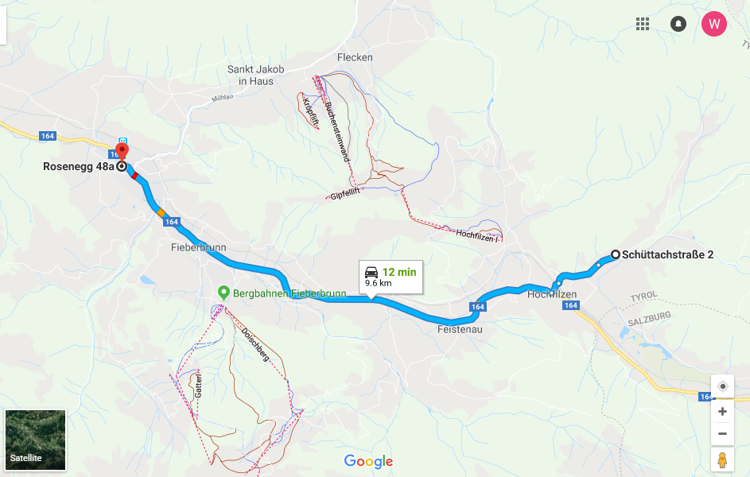
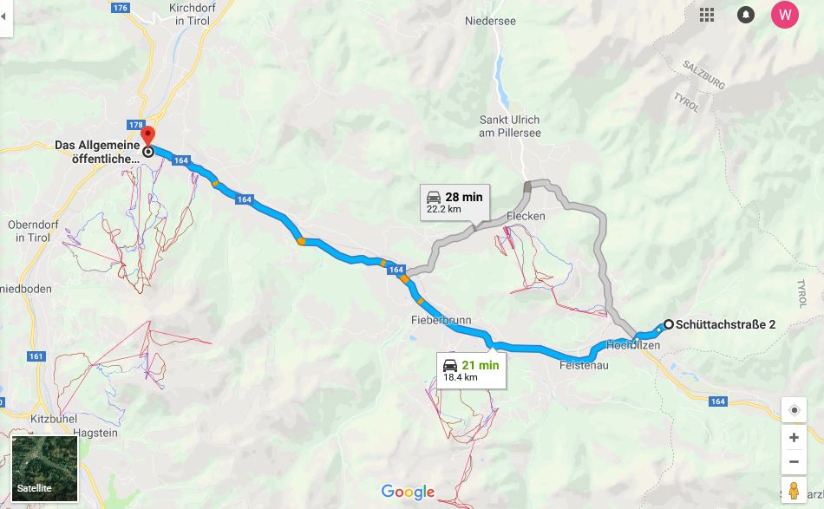

7

Exercise area & teams’ accommodation location

Annex B to
ExNWF20 Med Action Plan
dated 22 Oct 19

MOD Form 5010a
Introduced April 2008
MOD Risk Assessment Form

Establishment /Unit/Ship: | HQ 3 (UK) Div |  | Assessment No: | NWF / 20 / RA3 |  |  | Assessment Date: |  |  | 12 Jun 19
Section/Department: | Ex NORDIC WHITE FIST |  | Assessment Type  (Delete as appropriate; see Note 1)
 |  |  | Specific |  | Generic |  |  |  | Record of Dynamic Assessment
Activity/Process: Hochfilzen Stadium World Cup Biathlon Range – Medical Risk Assessment

Assessor |  |  | Line Manager Acceptance (See Note 2)
Name: | DJE Berry |  | Name: | A Johnson
Rank/Grade: | Maj; Ex Secretary |  | Rank/Grade: | Lt Col; Ex Director
Signature: |  |  | Signature:
Hazards  (Include Hazard Survey Number where applicable) | Who is at Risk? | Control Measures  (Specific existing Control Measures) | Risk Rating  (Likelihood X Consequence)  (See Note 3) | Additional Controls  (Each Control Measure is to be specific  and managed) |  | Residual Risk  Rating  (See Note 4) |  | Management Plan
 |  |  |  |  |  |  |  | Owner |  | Target Date | Comp  Date
Live Firing – Practice and Competitions
1. Injury by gunshot wound.  2. Skiing Collision injury. | Mil Personnel | TCs to ensure all team members are trained and certified. All team members have completed WHT. | 1 x 1 | RCO to receive copies of certificates before firing. |  | LOW |  | Ex Sec & RCO |  | 2 Jan 20
 | Mil Personnel | Each team member to receive Race Process Training before each race inc layout of range. | 1 x 1 |  |  | LOW |  | TD |  | 2 Jan 20
 | Mil personnel | Each team to provide 1:2 coaches to firers ratio during training. Range Staff and additional Staff during Race’s / competitions. | 1 x 1 | Range Staff to oversee and supplement coaches. |  | LOW |  | Ex Sec |  | 2 Jan 20
 | Mil Personnel | Weapons are only to be made ready and cleared when firer is in the correct firing position on the firing point. | 1 x 3 | Untrained firers are to have 1:1 supervision during firing practices. |  | MED |  | RCO |  | 2 Jan 20
Emergency Procedures – Immediate Actions
First Area / Medical Area |  | Suitable area marked off and set up on the range for immediate First Aid. Stretcher and First Aid pack. All personnel briefed of location. | 1 x 2 | Range Brief covers First Aid Point and appointed Range First Aider albeit that Mil Pers are all trained to MATT 3 standard. First Aid Kit (10 person or equivalent) as min. |  | LOW |  | Ex Sec |  | 2 Jan 20
Safety Vehicle |  | Suitable vehicle identified and located within 50m. | 1 x 1 | Range Brief covers Safety Vehicle. |  | LOW |  | Ex Sec |  | 2 Jan 20
Gunshot / Skiing Injury |  | Immediate First Aid / triage. All staff brief / trained. Range Staff / Race office to be contacted ASAP with Name, Location and injury. | 1 X 2 | Range Brief cover Emergency Procedures and actions inc casevac and helivac. |  | LOW |  | Ex Sec & RCO |  | 2 Jan 20
Hospital / Doctors |  | TCs to be made aware of local hospital at St Johann and local doctors in Fieberbrunn.  Austrian medical facilities, 2 paramedics and ambulance, will be on site during the races and will have primacy of casualty care and evacuation during races. TCs are to ensure that insurance covers helicopter extraction to hospital | 1 X 2 | Range Brief covers local hospital and doctors and emergency numbers including helivac if required. Race Office to be contacted via radio communications. |  | LOW |  | Ex Sec |  | 2 Jan 20
 |  | All Race Organisers / Range Staff / Race Office are in contact with each other by radio at all times. | Advisory | Spectators are excluded from the Range and Race finish areas which must be fenced off. Racers are supervised to ensure they exit these areas as quickly as possible. |  | LOW |  | Ex Sec |  | 2 Jan 20
 |  | Weather forecasts are displayed and updated on a regular basis via Race Office. | Advisory | Risk of cold injuries / hypothermia can be reduced by clear advice given at TC’s meetings linked to published daily weather forecast. |  | LOW |  | Race Office Manager |  | 2 Jan 20
 |  | An Army Technical Delegate appointed by the Ex Director is in attendance throughout the competition to advise on safety and technical matters. His work will be validated by a qualified British National Technical Delegate. | Advisory |  |  |  |  | Ex Dir |  | 2 Jan 20

Line Manager Assessment Review
(See Notes 2 and 5)
Review Date: | Aug 18 | Review Date: | Jun 19 | Review Date: | 20 | Review Date: | 21
Name: |  | Name: |  | Name: |  | Name:
Rank/Grade: |  | Rank/Grade: |  | Rank/Grade: |  | Rank/Grade:
Signature: |  | Signature: |  | Signature: |  | Signature:

Notes:
- If using a ‘Generic’ risk assessment, Assessors and Line Managers are to satisfy themselves that the assessment is valid for the task and that all significant hazards have been identified and assessed. If additional hazards are identified they are to be recorded and attached to the Generic assessment.

2 Line Managers are to note that they are responsible for production of the risk assessment and that they are signing to indicate that the risk assessment is suitable and sufficient, and they consider the risks to be acceptable.
3
High | Common, regular or frequent occurrence. | 3 | 3 Med | 6 High | 9 High
Medium | Occasional occurrence. | 2 | 2 Low | 4 Med | 6 High
Low | Rare or improbable occurrence. | 1 | 1 Low | 2 Low | 3 Med
Risk Matrix  Likelihood X Consequence |  |  | 1 | 2 | 3
 |  |  | Minor injury or illness. | Serious injury or illness. | Fatalities, major injury or illness.
 |  |  | Low | Medium | High

When recording the Risk Rating ensure that both the Likelihood and Consequence scores are included.

High | Improve control measures; consider stopping work. Conducting work at this level of risk is to be reported up the Line Management / Command chain.
Medium | Review control measures and improve if reasonably practicable to do so, consider alternative ways of working.
Low | Maintain control measures and review if there are any changes.

4 Record the residual Risk Rating to demonstrate that the risk has been reduced to an acceptable level; record Likelihood and Consequence scores.

5 Risk Assessments are to be reviewed:
- Annually.
- If there is reason to doubt the effectiveness of the assessment.
- Following an accident or near miss.
- Following significant changes to the task, process, procedure or Line Management.
- Following the introduction of more vulnerable personnel.
- If “Generic” prior to us

Mandated by 2019DIN07-090: Army European Winter Activity Instruction
Annex A to Exercise Nordic White Fist – SOP, dated 9 Oct 18.
JSP 751 Joint Casualty and Compassionate Policy and Procedures Vol 1 (Management of the Casualty) Issue 14 – July 14 provides details of the actions required.

