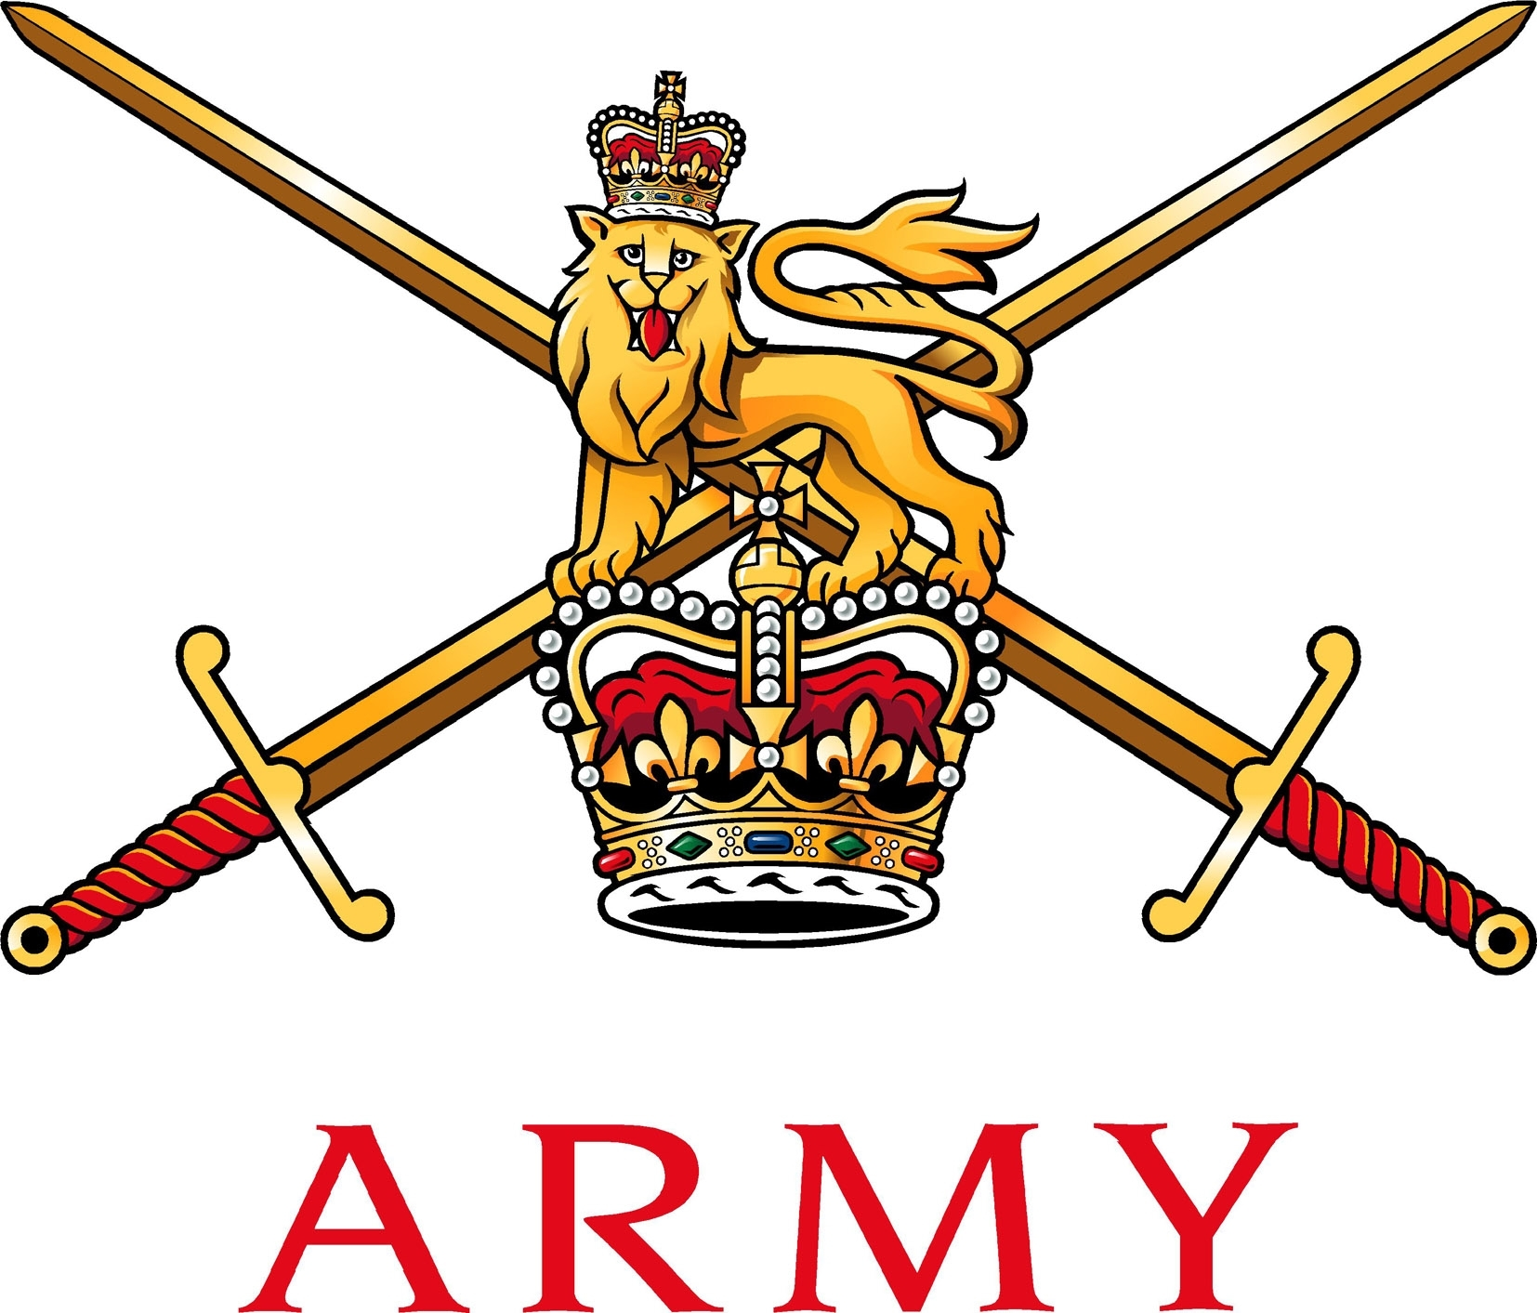

Army Ice Sports
C/O Army Winter Sports Association
Army Sports Control Board
MacKenzie Building, Fox Lines
Queen’s Avenue, ALDERSHOT
Hampshire GU11 2LB

Telephone: Mobile: 07957 564 677
Email: Military: Graham.Holmes294@mod.gov.uk
Civilian: grahamholmesluge@yahoo.co.uk

01 May 2019

WNGO EX RACING ICE TWO – ARMY ICE SPORTS CHAMPIONSHIPS 2020

References:

A. 2018DIN07-077 – Army European Winter Activity Instruction.

Introduction

- Ex RACING ICE 2 2020 (Ex RI2 20) is the annual Army Ice Sports Championships which will be held at Winterberg, Germany over the period 10 – 18 Jan 2020. The exercise comprises of a training week culminating with a race day. The outline elements of the exercise are:

  - Staff Arrival: Fri 10 Jan 20

  - Arrival and Registration: Sat 11 Jan 20

  - Training Week:

1) Bobsleigh, 12 – 16 Jan 20.

2) Luge and Skeleton, 13 – 16 Jan 20.

  - Race Day: Fri 17 Jan 20.

d. All depart: Sat 18 Jan 20.

Aim

- The aim of Ex RI2 20 is to train all male and female Novice, Junior and Senior participants on the Winterberg track culminating with a race day to determine the Army Ice Sports Champions for each discipline and category. This WNGO provides units and individuals the information required to plan for, and attend the exercise. A full administration instruction will follow NLT 31 Oct 19.

General

- Eligibility. Ex RI2 20 is open to all Army personnel from Regular and Reserve units. All participants must be medically fit (MFD) and have annual membership with the Army Winter Sports Association (AWSA) www.awsa.org.uk . Individuals must have successfully completed a Novice Ice Camp in order to drive a 2-man bobsleigh, skeleton or luge during this exercise. Absolute novices may attend but only as a 2-man bobsleigh brake person or in exceptional circumstances at the discipline Chairman’s discretion.

- Participation. Exercise entry forms are on the AWSA MOSS site and the AWSA web page. All entry forms are to be submitted to Sec Luge, WO2 Graham Holmes by NLT 06 Jan 20.

Administration

- Accommodation.

a. Staff. Staff accommodation will be at Hotel Winterberg Resort GmbH In der Renau 1, 59955 Winterberg Telefon +49 (2981) 91 9-0Fax +49 (2981) 91 9-100, www.hotelwinterberg-resort.de
info@hotelwinterberg-resort.de

a. Participants. All participants are to book their own accommodation. Competitors are to source their own accommodation in and around Winterberg where there is an abundance of local Gasthofs and pensions.

b. Arrival/Departure. All personnel should aim to arrive between 1400 to 1700 hours on the 11 Jan 20. Departure from the exercise location will be on the morning 18 Jan 20. For all queries on accommodation please liaise with the undersigned.

c. Cost. The cost of accommodation is approximately €45.00 to €70.00 per person/per night.
- Transport. Individuals and teams are to use unit MT for transport support. Participants require transport to and from the exercise location from base units. Details on claims in support of transport costs are included within Reference A. The closest airport to Winterberg is Dortmund and there is a train and bus service from the airport to Winterberg.

- Funding. The estimated cost for an individual to attend Ex RI2 20 is £500 - £600 which includes travel, fuel, insurance, equipment, accommodation and feeding. All costs are to be paid by individuals and/or units. Track fees and equipment hire will be paid for by the AWSA. An approximate breakdown of the costs per person is shown in the table below.

Ser | Item | Approximate Cost | Remarks
1 | Accommodation | €300-500 | ½ board – 7 nights
2 | Entry fee | €10 | Per person
3 | Vehicle hire/fuel card | 0 | Unit MT supported
4 | Track fees | 0 | Paid by AWSA
5 | Equipment hire | 0 | Paid by AWSA
6 | Personal safety equipment | £50-100 | Helmets, gloves etc (Discipline dependent).
7 | Lunch | £80 | Based on £10 per day
8 | Ice sports insurance | £25 | Per person
9 | AWSA Membership | £15 | Annually

- Personal Contributions. Units are requested to support participants in order to keep personal contributions to a minimum/acceptable level. Ideally participants should expect to pay no more than third of the total cost.

- Additional Funding. Additional funding may be available through COPF, Corps funds, the Berlin Memorial Fund (if applicable) and Army Sports Lottery grants. If participants are members of the Army Sports Lottery (ASL), and holding tickets, they will be able to claim a Winter Sports Activity Grant (post season); see armysportslottery.com for more information.

- Equipment. All major Ice Sports equipment will be provided. Participants are required to bring the following to the exercise:

a. Bob. Crash helmet (with certified BSI Kite mark, in date), gloves, track spikes (further info at bobsleigh@awsa.org.uk).

b. Luge. Gloves (issue flying gloves/cross country skiing gloves recommended) (further info at luge@awsa.org.uk).

c. Skeleton. Gloves and ice crampons (further info at skeleton@awsa.org.uk).

11. Documentation. All participants are to bring the following documentation to Ex RI2 20:

a. MOD 90.

b. EHIC Cards. EHIC cards are available free of charge online at www.ehic.org.uk.

c. Passport. All personnel are to travel with in date passports which have a minimum of six months remaining prior to the expiry date.

d. Insurance. Insurance can be obtained from Insignia Underwriting (Tel: 01722 597980) website: www.insigniaunderwriting.co.uk. Contact: richard.dorman@insigniaunderwriting.co.uk or admim@insigniaunderwriting.co.uk.

Registration /ENDEX

12. Registration for all participants will take place at 1700hrs on Sat 11 Jan 20, location TBC. Participants are to bring all documentation as per Para 12. Failure to produce any of the above documents will result in a person unable to slide.

13. Participants will be released from Ex RI2 20 on the morning of 18 Jan 20 when accommodation costs have been paid and all equipment returned. ENDEX for participants will be on return to unit lines.

Selection for the UKLFWSA Service Championships

14. The UKLFWSA Service Championships will be held at Koingssee Mar 20. Selection for the Army Squad will take place during Ex RI2 20 and will be confirmed post racing. Those selected will be issued with an updated Exercise RI3 20 Administration Instruction at the end of the Army Championships.

Summary

15. The 2020 Army Novice, Junior and Senior Army Championships promises to be a larger event than previous years. Regiments and Corps from across the Army will send competitors to race 2-man bobsleigh, skeleton or luge in a professional yet fun environment. The key focus for the week is primarily to train and develop discipline skills on a new track then decide, through competition, the male and female Novice, Junior and Senior Army Champions. Selection of the Army Squad for the UKLFWSA Service Championships will be confirmed during Ex RI2 20.

{original signed}

GR Holmes
WO2
Secretary Army Luge

Director Army Ice Sports*
Ice Sports Distribution List*
Unit Adjutants*

This instruction will be superseded Sep 20.
There are regular flights from Stanstead to Dortmund (Ryanair). The exercise location and recommended accommodation is approximately 1 hour 35 minutes to 1 from Dortmund Airport.
Further information can be found at Tourist Information, info@winterberg.de .
Note that other websites may charge up to £50 to process the application, so please ensure your soldiers use the official NHS/Gov site.

