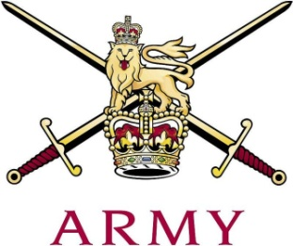
ARMY CRESTA

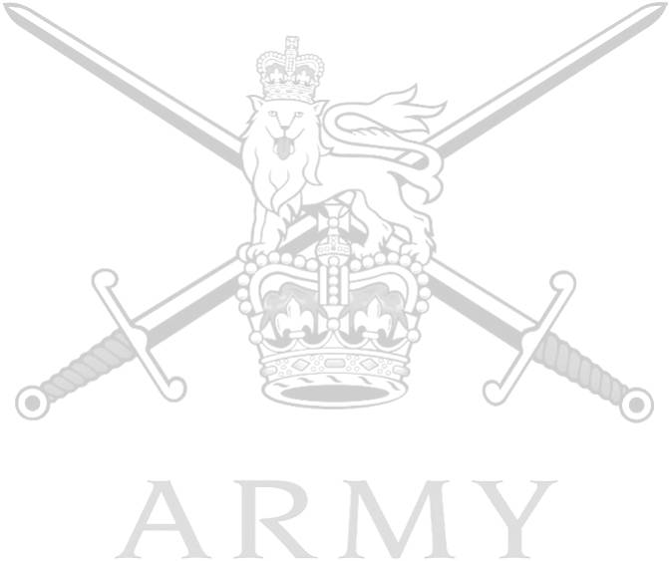
Scots Guards Cup

28th January 2019

 |  |  | 1st Course |  | 2nd  Course |  | Grand Total
1 | Capt T Wythe | The Royal Lancers, (Queen Elizabeths' Own) | 54.94 | 55.01 |  | 109.95
2 | Maj P.J.R. Chishick | The Life Guards | 55.32 | 55.42 |  | 110.74
3 | Capt J.C. Palmer-Tomkinson | 1st Battalion Grenadier Guards | 58.02 | 57.27 |  | 115.29
4 | Capt J.B. Barnes | The Blues & Royals | 58.47 | 56.98 |  | 115.45
5 | Capt S. Pryor | The King's Royal Hussars | 58.88 | 58.00 |  | 116.88
6 | CSjt T.C. Armon-Jones | The Rifles | 58.24 | 59.04 |  | 117.28
7 | LCoH R.J. Tonkin | The Blues & Royals | 59.76 | 59.06 |  | 118.82
8 | Maj R. M. Morgan | Royal Wessex Yeomanry | 59.79 | 59.12 |  | 118.91
9 | Pte C. Evans | Adjutant General's Corps | 79.98 | 70.83 |  | 150.81

Fastest Time of Race: Capt T. Wythe 54.94

