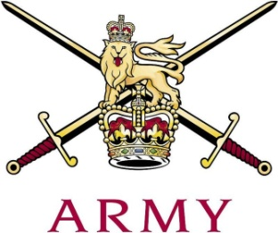
ARMY CRESTA

25th January 2019

Junction Handicap 2019

Net
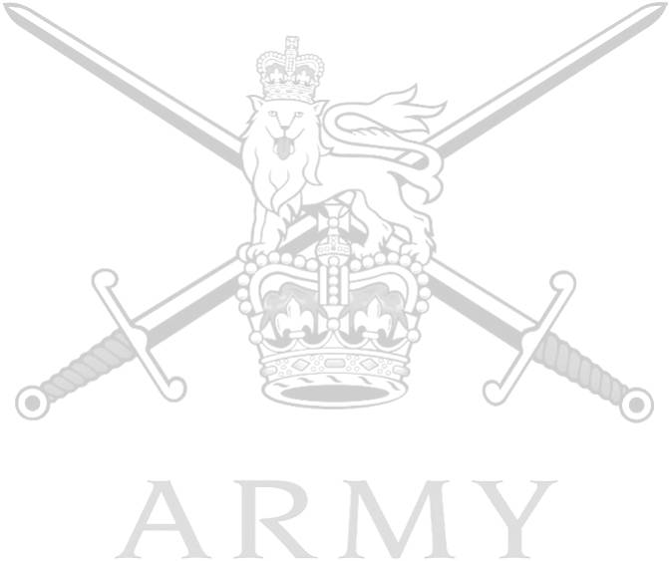
H'Cap 1st 2nd 3rd Total
Capt Wythe | RL | +0.5 | 44.70 | 44.11 | 43.95 | 132.76
Capt Pryor | KRH | 1.5 | 46.11 | 43.83 | 43.63 | 133.57
Maj Chishick | LG | 0.5 | 44.71 | 44.32 | 44.55 | 133.58
Capt Palmer Tomkinson | GG | 2 | 44.55 | 44.79 | 44.46 | 133.80
Lt Fry | QRH | 10 | 45.70 | 44.65 | 44.24 | 134.59
Lt Titcombe | RL | 10 | 45.82 | 43.94 | 45.41 | 135.17
Lt Sleeman | QRH | 10 | 46.50 | 44.43 | 44.68 | 135.61
Capt Barnes | RHG/D | 1 | 45.37 | 47.19 | 43.98 | 136.54
Tpr Wooley | QRH | 2.5 | 47.24 | 44.71 | 45.07 | 137.02
LCpl Wiggins | KRH | 8.5 | 46.48 | 46.20 | 45.85 | 138.53
Tpr Price | RL | 12 | 49.34 | 47.28 | 46.88 | 143.50
Lt Colquhoun | RL | 10 | 47.94 | 47.99 | 48.13 | 144.06
Lt J Heelas-Jorgensen | KRH | 10 | 45.71 | 51.75 | 48.19 | 145.65
Lt Howard-Keyes | LG | 10 | 48.15 | 49.28 | 48.40 | 145.83
LCpl Reynolds | KRH | 12 | 52.06 | 56.10 | 53.85 | 162.01
CoH Tonkin | RHG/D | 2 | 46.13 | 44.68 | Fall (S)
Lt Gray | RL | 10 | 43.78 | 45.20 | Fall (S)
Tpr Fairbairn | RHG/D | 2.5 | 44.78 | 45.49 | Fall (S)
Lt Worth | KRH | 10 | 49.65 | Fall (S)
Lt Ide | GG | 3 | 45.09 | Fall (S)
Cpl Williams-Tanton | RL | 8 | 45.31 | Fall (S)
Cpl Liegh | Int Corps | 12 | 43.74 | Fall (S)
Tpr Pearson | QRH | 12 | Fall (S)
Fastest Time of Race: T. Wythe 43.45
Fastest Speed of Race: T. Wythe 75.62mph

ARMY CRESTA

The 17th/21st Lancer Cup - Inter-Regimental Pairs 2019
 |  |  | 1st Course |  |  | 2nd Course | 3rd Course |  | Grand Total
1 | Capt Pryor | KRH |  | 47.61 | 45.33 |  | 45.13
 | LCpl Wiggins | KRH |  | 54.98 | 54.70 |  | 54.35 | 604.20
2 | Maj Chishick | LG |  | 45.21 | 44.82 |  | 45.05
 | Lt Howard-Keyes | LG |  | 58.15 | 59.28 |  | 58.40 | 621.82
3 | Lt Fry | QRH |  | 55.70 | 54.65 |  | 54.24
 | Tpr Wooley | QRH |  | 56.74 | 54.21 |  | 54.57 | 660.22
4 | Tpr Price | RL |  | 61.34 | 59.28 |  | 58.88
 | Lt Colquhoun | RL |  | 57.94 | 57.99 |  | 58.13 | 707.12

The Novice Cup 2019

 |  |  | 1st Course | 2nd Course | 3rd Course |  | Grand Total
1 | Tpr Wiggins | KRH | 54.98 | 54.70 | 54.35 | 164.03
2 | Lt Titcombe | RL | 55.82 | 53.94 | 55.41 | 165.17
3 | Tpr Wooley | QRH | 56.74 | 54.21 | 54.57 | 165.52
4 | Lt Sleeman | QRH | 56.50 | 54.43 | 54.68 | 165.61
5 | Lt Colquhoun | RL | 57.94 | 57.99 | 58.13 | 174.06
6 | Lt J Heelas-Jorgensen | KRH | 55.71 | 61.75 | 58.19 | 175.65
7 | Tpr Price | RL | 61.34 | 59.28 | 58.88 | 179.50
8 | LCpl Reynolds | KRH | 64.06 | 68.10 | 65.85 | 198.01
 | Tpr Fairbairn | RHG/D | 45.78 | 46.49 | Fall (S)
 | Lt Worth | KRH | 59.65 | Fall (S)
 | Cpl Liegh | Int Corps | 55.74 | Fall (S)
 | Tpr Pearson | QRH | Fall (S)

