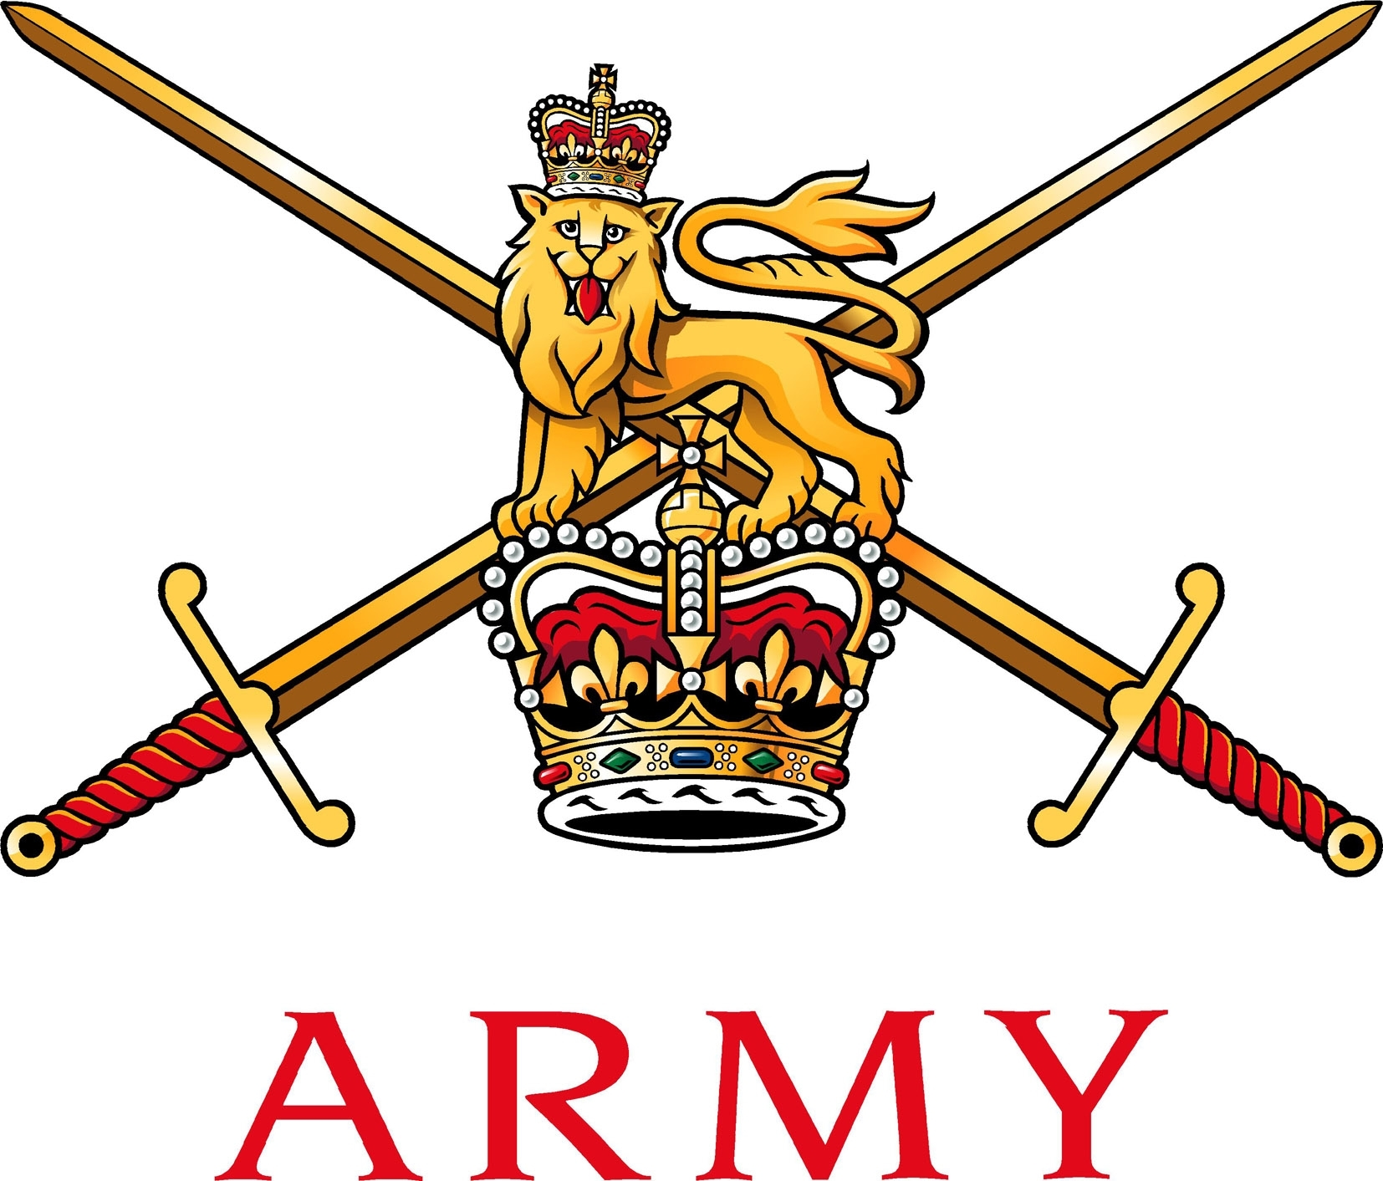
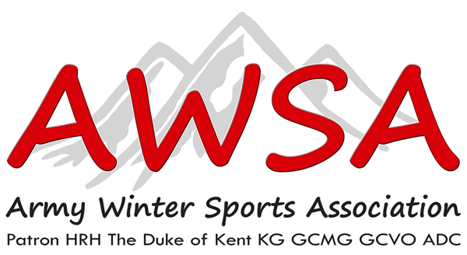

Army Ice Sports
C/o Army Winter Sports Association
Army Sports Control Board
MacKenzie Building, Fox Lines
Queen’s Avenue, ALDERSHOT
Hampshire, GU11 2LB

Telephone: Mobile: 07957 564 677
Email: Military: Graham.Holmes294@mod.uk
Civilian: grahamholmesluge@yahoo.co.uk

3 October 2018

AISC/RI1/AI18/19

See Distribution

ADMINISTRATIVE INSTRUCTION – EXERCISE RACING ICE 1, ARMY NOVICE ICE CAMP 2018

A. 2018DIN07-077 Army European Winter Activity Instruction 2018/19.
B. 2018DIN10-016 Army Sports Lottery.
C. 2017DIN10-006 Berlin Infantry Brigade Memorial Trust Fund.
D. AGAI Vol 1 Ch 5.
E. JSP 456, Vol 2, Ch 7, Defence Catering Manual.
F JSP 752, Ch 3-6, Tri-Service Regulations for Expenses and Allowances.
G. 2018DIN10-021 Travel at Public Expense for Army Sport.
H. SO BFG 4303 dated 4 Jan 2016.
I. JSP 800 Vol 5 Part 2. Defence Movement and Transport Regulations1 September 2017.

INTRODUCTION

- The Ice Sports Season 2018/19 commences with the Army Novice Ice Sports Camp, Ex RACING ICE 1, which will be held at the Olympia-World Bobsleigh track Igls, Innsbruck, Austria over the period 2 – 15 Dec 18. All participants undergo professional instruction for five training days.

AIM

- Ex RACING ICE 1. The aim of Ex RACING ICE 1 (ExRI1) is to:

a. Provide a professional and challenging exercise which meets the criteria of Army sport and fulfils the AWSA President’s intent of delivering ‘Sport for All’ whilst maximising talent development.

b. Develop individual ice sport skills and capabilities through professional formal instruction.

c. Develop participant attributes such as courage, determination, leadership, self-confidence and teamwork through a well-organised sporting event.

d. Further develop the Army Ice Sports skill base in terms of awareness, participants, knowledge and experience.

- Develop talent in all three disciplines that will form the back bone of the Army team in the 2018/19 Inter Service Championships and build on Army successes in previous seasons.

- Administrative Instruction. The aim of this administrative instruction is to provide Ex RI1 staff and participants the necessary information and administrative requirements to be able to prepare for and partake in the exercise.

SEASON FORMAT

- The profile of ice sports across the Army remains high. The Army Novice Ice Camp is designed to develop talent, with a view to creating a team capable of winning the Inter Service Ice Sports Championships, whilst maximising participation at the Army Championships. The season format is as follows:

              - Ex RACING ICE 1 - Army Novice Ice Camp, Igls, Innsbruck, Austria (2 – 15 Dec 18). During the exercise participants will learn how to drive a 2-man bobsleigh, luge or skeleton in a safe, professional and enjoyable manner.

              - Ex RACING ICE 2 - Army Ice Sports Championships, Koingssee, Germany (19 – 26 Jan 19). The Army Championships are open to competitors from across the Army (Regular and Reserves). Competitors may enter as individuals or preferably as Regimental/Corps teams and compete in the Army Championships for their Regiment/Corps. Only competitors who have completed a Novice camp can apply for Ex RACING ICE 2. See AWSA website www.awsa.org.uk for further information. All competitors are to book their own accommodation for this exercise.

              - Ex RACING ICE 3 - Pre- training week (17 – 22 Feb 19) and Inter Service Ice Sports Championships (24 Feb – 1 Mar 19). Individual performances through-season and/or at the Army Ice Sports Championships are used to select the strongest possible Army team. This team will consist of no more than 14 bobsleigh (7 x 2-man crews), 13 skeleton and 8 luge athletes.

              - British Bobsleigh & Skeleton Championships and British Luge Championships. Due to funding reasons and world circuit commitments, a 2018/19 Season BBSA Championships has not been planned.

PARTICIPATION

- Eligibility. Ex RI 1 is open to all Army personnel from Regular and Reserve units who are MFD.

- Army Winter Sports Association (AWSA) Membership. To participate in any Army Winter Sports event athletes must be a member of the AWSA; membership is £15 per annum. Application forms are at Annex A and on the AWSA website. The AWSA contributes non-public funding (sponsorship & charity) to all events. Further information can be obtained by contacting the Secretary AWSA.

Athlete’s Declaration. Participants must be fit and able to pass their annual fitness tests. All participants are to complete and sign an Athlete’s Declaration (see Annex B) stating they are fit to train. These are to be handed in on registration. Ex RI1 will not allow medically downgraded personnel to take part in training unless they have Annex 26 from PAP10 v4. If an unfit individual attends they will be RTUd at own or Unit expense.

AUTHORISATION & CLEARANCES

- Exercise Authority. Ex RI1 is authorised by the Army Sports Control Board (ASCB).

- Diplomatic Clearance (DIPCLEAR). DIPCLEAR is the political authority to transit through or conduct WSA in countries outside UK. It is granted by the appropriate British Embassy Defence Section (Def Sect), or HQ British Forces Germany (HQ BFG) for Germany. Transiting is travelling through a country without taking part in any WSA in that country. The Event Organiser will apply through the AWSA for DIPCLEAR for officials and participants to travel by Ex RI1 transport (to and from UK or advance party vehicles).

- Transit and Staff Clearance. The AWSA will apply for Transit and Staff Clearance for officials and participants of Ex RI1.

FINANCES

- Participant Costs. The cost of the Ice Camp is part of a package deal that includes; travel to and from Austria, half board accommodation, coaching and track fees and equipment hire. In addition to the package cost, personal will be required to cover adequate personal protective equipment, supplemental food and travel/winter sports insurance. Units are encouraged to support individuals in order to keep individual costs to a minimum. Other costs can be covered from CILOR, Army Sports Lottery grants, COPF and the Berlin Memorial Fund (if applicable). The cost to attend the exercise is:

Item | Cost £ | Remarks
UK based units | 500 | Package deal
Germany based units | 400 | Package deal
Royal Navy | 700 | Package deal
Motorcycle helmet | Approx. 50 | Bobsleigh only
Ice sports insurance | 25 | Per person, per week

NON-PUBLIC FUNDING

- Army Sport Lottery (ASL). Lottery members are eligible to claim ONE Winter Sports Grant per season equating to £25 per ticket held. This grant is claimed centrally by the AWSA and the grant amount is deducted from your entry fee. E.g. if your entry fee is £500 and you hold 3 lottery tickets then £75 (3 x £25) will be deducted from your entry fee and £425 would be due. A final check of all lottery membership will be made on 19 November (day before balancing payments become due) and any adjustments due will be made prior to balancing payments being taken. New applications or applications for the uplift of ticket numbers MUST be received by the ASL by NLT 1200hrs on 31 October 2018 in order that payment is taken from your November salary. For full details see www.armysportslottery.com

- Berlin Infantry Brigade Memorial Trust Fund (BIBMTF). Units may apply for a Winter Sports grant of circa £25 per person, subject to confirmation, from the BIBMTF charitable trust. These bids are to be consolidated at unit level to encompass all disciplines and are to be submitted electronically direct to the Trust Secretary, email: isvcsagency@easynet.co.uk, copy to Secretary ASCB. Grants will be allocated from October onwards.

SPONSORSHIP AND DONATIONS

14. Sponsorship of the AWSA and individual disciplines is subject to separate ASCB instructions.

15. Units fortunate enough to obtain sponsorship or a voluntary donation are to be aware that this is to be applied to offset non-public costs. Therefore, MOD resources and assets must not be used to raise such sponsorship. MOD officially-headed paper is not to be used to give an impression that sponsors are supporting an official MOD organisation; correspondence must be on behalf of the PRI, not on behalf of the unit. Sponsors may not use Regimental badges or the Army Badge (crossed swords) in promotional material linked to non-public sponsorship. If vehicles are provided as part of the sponsorship, the cost of maintenance, fuel, insurance, etc. must be met by the sponsor or from non-public funds.

16. All dealings with sponsors or potential sponsors must adhere to the following key principles: impartiality; honesty and integrity; avoidance of conflict of interest; safeguarding reputation; accountability; regularity and propriety; avoidance of official endorsement of sponsor and/or their products. It is recommended that written agreements are put in place for all sponsorship activities. Any queries regarding sponsorship should be referred to the AWSA Sponsorship Secretary via email at sponsorship@awsa.org.uk . All Team Captains/individuals fortunate enough to be in receipt of sponsorship are to inform OIC Protocol and the Exercise Commander (Ex Comd) at Registration.

17. Corps & PRI Funds. Regt and sub-unit PRI funds can be used, and are encouraged, to offset individual costs.

PUBLIC FUNDING

18. CILOR. Unit representatives or individuals are responsible for financing their own feeding outside of that provided with the accommodation package. Units/Individuals may apply for CILOR to cover lunch costs. No payments or authorisations will be issued whilst at Igls or post exercise. Accounting for CILOR is to be conducted in accordance with the JSP. See Para 30 for more information.

19. Track Fees. The AWSA will fund all track fees.

20. Allowances and Charges. Except where specifically authorised, Local Overseas Allowance (LOA) and Longer Separation Allowance (LSA) are inadmissible for Sport or other WSA. Subsistence allowances are not admissible for participants or competitors in Sport or other WSA. Key Safety Officials in Sport, including WSA, may be eligible. Individuals who are not accommodated at Public expense may be refunded Single Living Accommodation charges and the Daily Food Charge, when incurred.

RESPONSIBILITIES

21. Exercise Commander. Maj G Cooke RLC is the Ex Comd for Week 1 and Maj TDE Haskell RA for Week 2. They are to conduct the exercise on behalf of Director Army Ice Sports.

22. Discipline OICs. Discipline OICs are responsible for the safe conduct of the individual discipline and the delivery of the individual discipline training. Each sliding discipline will have a nominated OIC, as follows:

              - Bobsleigh. Maj G Cooke RLC, Chair Army Bobsleigh Association.

              - Skeleton. Maj TDE Haskell RA, Chair Army Skeleton Association.

              - Luge. Maj L Wyatt RE, Chair Army Luge Association.

23. Unit representatives/Individuals. Unit representatives (or individuals, as appropriate) are responsible for submitting the Athlete’s declaration, CILOR, maintaining discipline and all other matters pertinent to themselves or their team (including AWSA membership, ASL membership, insurance and medical requirements prior to travel to Ex RI1).

24. Medics. DMG North are providing a military doctor and nurse for the duration of the exercise. They will be responsible for the provision of routine and emergency medical cover to athletes, staff and military visitors as required during the event. This will include, but is not limited to, the provision of emergency medical treatment and triage during on-ice training.

25. OIC Accommodation. Secretary Army Luge Association (Sec ALA) is responsible for the coordination and management of all accommodation bookings for staff, participants and selected visitors to the exercise.

26. Coaches. Coaching is discipline specific. Each discipline is to have a minimum of one coach, with two trackside support staff (three for bobsleigh). The provision of coaching support is the responsibility of the Discipline OIC. The exercise coaches are listed within the staff list at Annex D.

SERVICE SUPPORT

27. Accommodation. The POC for accommodation is Sec ALA. Note:

              - Accommodation is single-sex shared rooms.

              - Accommodation is half board (breakfast and dinner); cost is included within the exercise package.

              - Proprietors are very accepting of military guests and cater for specific needs, but note that it is a public hotel and non-military guests may well be present. Any issues are to be made known to Sec ALA; this protects the reputation of the Army Ice Sports committee and the rights of individuals.

                - d Accommodation for the duration of Ex RI 1 is at Gasthof-Pension Walzl, Dorfstrasse 56, A-6072 Lans, Tirol, Austria. Tel. +43 512 370380, www.gasthof-walzl.at.

28. Advance Parties. The Advance Party will move discipline equipment and staff from Ilford, UK from Fri 30 Nov 18. OIC Advance Party is Sec ALA. Timings and details to follow in the confirmatory instruction.

29. Subsistence. All Safety Officials and Military Staff may claim for day subsistence (food) during transit and lunch meals (only) during Ex RI1. Ex RI1 Safety Officials and Military Staff are listed at Annex C.

30. CILOR. Staff/individual participants/units are to apply for CILOR to cover their lunch through their unit admin chain in advance of deploying on the exercise. CILOR will not be authorised without TLB authority. Units are to inform their TLB of any changes to their CILOR requirements as they occur, such as individuals being RTU’d through injury, etc. Note that personnel in receipt of FIA are not entitled to claim CILOR.

31. Travel.

              - Participants. All Germany based participants are to make their own way to Igls by the most cost effective means possible. All UK based participants will fly from London Gatwick (LGW) to Innsbruck airport (INN). Transport will be provided from the airport to the accommodation. All participants are to arrive LGW two hours prior to flight departure. Units/individuals are to ensure that participants arrive LGW on time.

Week 1 | Week 2 | Timing | Action
2 Dec | 9 Dec | 0625 | Arrive LGW and Check in
 |  | 0825 | Flight Easy Jet 8293 Departs
 |  | 1125 | Flight arrives INN (local time)
 |  | 1200 | Coach departs INN to Gasthof Walzl, Lans
8 Dec | 15 Dec | 0800 | Coach departs Gasthof Walzl, Lans to INN
 |  | 1050 | Flight Easy Jet 8292 departs
 |  | 1145 | Flight arrives LGW (local time)

VEHICLES AND DRIVING

32. Exercise White Fleet Requirements. Advance Party vehicles are detailed in the Transport Plan. This will be distributed with the Confirmatory Instruction.

33. Driving. Whilst the roads are usually kept clear, alpine weather can cause very hazardous driving conditions. Individuals driving from Germany must ensure that unit vehicles comply with the legal requirements for vehicles in Austria (and any transit countries) as well as snow chains. Advice on this matter can be sought from Unit MTOs.

34. Train. For train users, there is a regular bus service running from outside Innsbruck station to Igls/Lans at a cost of approx €5 and a taxi should be no more than €30.

EQUIPMENT

35. Army Ice Sports will provide technical equipment for Ex RI1. All bobsleigh personnel must arrive with a British Standard serviceable helmet. The use of approved helmets is compulsory.

              - Luge & Skeleton. The coordination and movement of luge and skeleton bobsleigh equipment to the exercise is the responsibility of Sec ALA and Sec ASA

              - Bobsleigh. The coordination and movement of luge and skeleton bobsleigh equipment to the exercise is the responsibility of Chair Bobsleigh.

              - Personal PPE. Participants are required to provide individual items of PPE (different for each discipline) as detailed below:

      - Bobsleigh. Crash helmet and gloves (further info from bobsleigh@awsa.org.uk).

      - Luge. Gloves (issue flying gloves/cross country skiing gloves recommended) (further info from luge@awsa.org.uk).

      - Skeleton. Gloves (not too thick), padding for arms, wrists and ankles and appropriate footwear for walking on ice. (further info from skeleton@awsa.org.uk).

MEDICAL

36. Medical. The ExRI1 staff includes two military AMS personnel. A full medical estimate has been conducted and a Medical Instruction is at Annex D. Participants are to note:

              - Trackside. The First Aid Post at the track is located at the Zeilhaus. The doctor and nurse will man this facility and provide emergency first aid trackside throughout sliding.

              - Routine medical cover. The medic will provide routine healthcare cover, but this will be limited and focused on injuries received through sliding. There are several private doctors and pharmacies in Innsbruck. Ice Sports Insurance, an EHIC (see below) and a passport will be required for treatment at Innsbruck Hospital. Personnel are warned that private treatment must be paid on the day then claimed back through insurance.

c. Medical Stores. Basic medical stores will be brought to the exercise however this will not include routine supplies ongoing medical issues.

INSURANCE

37. European Health Insurance Card (EHIC). All participants and staff must possess and travel with a valid European Health Insurance Card (EHIC). The EHIC is available free of charge online at www.ehic.org.uk. Other websites may charge up to £50 to broker the application, so please ensure you use the official NHS/Gov site. Allow sufficient time for processing and issue and delivery of the card prior to deployment.

38. Travel Insurance. All attendees are strongly advised to obtain travel insurance to cover luggage, personal and loaned equipment, travel delay and personal injury sustained off-ice. Check with your bank or building society to see if already provided, or alternatively arrange single-trip travel insurance which can be done as an extension of the Ice Sports insurance for a small additional fee.

39. Ice Sports Insurance. All personnel sliding (staff and participants) must have valid ice sports insurance. There are numerous providers who offer this cover, but of note are Insignia Underwriting (tel: 01722 597980). Email richard.dorman@insigniaunderwriting.co.uk Web Page www.insigniaunderwriting.co.uk or Towergate Wilson. Unit representatives/individuals should quote AWSA in order to ensure a suitable cover is understood and a discount provided. Individuals insured are to ensure their provider covers them not only for participation in their chosen discipline, but also for organized training including permanent disability, injury to themselves and others and helicopter evacuation whilst training on ice. Proof of insurance will be checked at Registration.

ARMY RESERVES

40. Reserve Service Days. Attendance at Ex RI1 is at the discretion of the Commanding Officer of an athlete’s parent unit. The class of training is to be determined by the unit, not the exercise organisation. This approach is to ensure that Reserve personnel can be actively encouraged to attend rather than constrained by a lack of available RSDs, as well as to ensure that unit commanders’ freedom over RSD allocation is respected. It is requested that exercise staff are paid RSDs and are paid for bounty qualified RSDs, for their work if possible, as without their dedication, efforts and hard work, the exercise would not be possible.

41. Churchill. Units sending reservist participants are to allocate RSDs against a JAMES code, appropriate for army-level sport (participation, visit or tasking as appropriate).

MISCELLANEOUS

42. Dress. Dress for all Army winter sports activity is civilian attire. No military clothing or equipment is to be used or worn during Ex RI1.

43. Duty Status. All military participants are to ensure that they are posted as ‘on duty’ for the duration of the exercise on Unit Part 1 Orders prior to deployment. There are various other activities on offer in the area. If individuals choose to participate in these, they will be classed as ‘off duty’ during that activity. Those activities include, but are not limited to, skiing, snowboarding, cultural/social visits in the local area and tobogganing.

44. Passports. All personnel are to ensure they travel with a valid and in-date passport, valid until at least 31 Mar 19. Non-British passport holders are to ensure they obtain any necessary visas to enter Austria.

45. Driving License. All drivers are to ensure they travel with a valid and in-date driving license, valid until at least 31 Mar 19.

46. Carriage of Identification in Austria. All personnel are reminded that it is a legal requirement to carry a form of photographic identification at all times whilst in Austria.

47. VENUE

              - Location. The village of Lans is located 15 minutes by road from Innsbruck and 30 minutes from Innsbruck airport. Participants will be based in and around the villages of Lans and Igls, which are the villages nearest the track. Access to both villages is by road, bus or tram from Innsbruck.

              - Access to the track. All training will be conducted on the OlympiaWorld Bobbahn at Igls, which is approximately 2 km from Lans. Access to the track is by road. There is a reliable bus service from Lans to the ski area adjacent to the track, staff will assist participants in movement to and from the track.

              - Weather Conditions. All training will take place at an altitude in excess of 1200m. Wind chill and temperatures can fall to below minus 20C very quickly. Individuals are responsible for being correctly equipped and dressed for the conditions at all times during the exercise. Warm clothing is recommended.

TIMINGS

48. A detailed MEL will be given once in location.

REGISTRATION

49. Unit representatives/individuals are to conduct the following at Registration:

              - Register participants.

              - Provide completed and signed Athlete’s Declaration Form for all unit personnel.

              - Bring Passport, EHIC and ice sports insurance for all participants.

              - Move into accommodation (if not already completed).

COMMAND AND CONTROL

50. POC and Staff List. The ExRI1 POCs and full staff list are detailed at Annex C.

51. Unit representatives (Individuals if only member from unit). Regiments are to appoint a unit representative who will be responsible for the management, organisation and conduct of their participants. Unit representatives are to action the following:

              - Report to Registration with all necessary paperwork/payments (including; insurance docs, athlete declarations etc.).

              - Attend daily post training briefs and any other meeting as requested.

52. Discipline. It is of the utmost importance to maintain good relations with the local authorities and populous. This has been established over many years of training and competing in this location, notwithstanding the status of the Igls track as the UK’s declared home ice sports track. Misbehaviour, conduct unbecoming or failure to settle bills will not be tolerated. The Ex Comd reserves the right to Return to Unit (RTU) any competitor not meeting the required standards.

53. Driving . Drivers are to comply with current service regulations and be aware that speed limits are rigorously enforced with large on-the-spot fines for drivers. All drivers are to ensure that they have a current and valid driving license, FMT 600 and European Matrix Test prior to deployment. Only personnel authorised and qualified to do so may drive white fleet vehicles (this includes civilian personnel where explicit letters of authority have been issued by the AWSA). Only named drivers may drive locally-rented vehicles. All drivers and commanders are responsible for enforcing drivers hours and ensuring nominated drivers are fit to drive and do not exceed the alcohol limit (Austria allows only 0.5 milligrams of alcohol to be present in the blood when driving, compared to the UK’s 0.8 milligrams). This is particularly prevalent when driving to the track in the morning.

SAFETY

54. Ice sports are by their very nature dangerous activities which if undertaken incorrectly present a serious risk to the physical well-being of participants. Therefore, it is essential that a proper approach to managing risk is adopted and followed.

55. Risk Assessment. A detailed risk assessment for Ex RI1 will be held by the exercise organisers. Activities covered by standard Army or Joint Service instructions do not require further risk assessment (e.g. driving activities for which JSP 800 applies). Guidance in standard military publications for those activities is to be observed and adhered to.

56. Compassionate and Casualty Reporting Procedures. Discipline OICs, unit representatives and individuals are responsible for ensuring that all accidents or incidents are reported directly to the OIC Discipline and onwards to the Ex OIC to facilitate timely and accurate formal reporting.

COMMUNICATIONS

57. Telephones. Authority is to be sought to reimburse exercise staff for all exercise related telephony charges using the JPA mechanism or through invoicing (for civilian staff).

58. Radios. Each member of staff will be issued with a radio and batteries for the duration of the event. Discipline OICs are to ensure that these are available throughout the exercise. Radios will be coordinated centrally and managed by Sec ALA.

59. Data. Free Wi-Fi is available at the Bob Café at the track and in the hotel.

60. IT Equipment. Personnel are to ensure they hold a carriage certificate and the appropriate permission to carry any MOD IT equipment they bring with them abroad.

POST EXERCISE REPORT (PXR)

61. A PXR is to be compiled by exercise organisers and forwarded to Secretary ASCB within one month of the end of the exercise; Secretary ASCB will acknowledge receipt.

SUMMARY

62. Ex RI1 offers the opportunity for soldiers and officers from across the Army (Regular and Reserve) the chance to learn how to drive a 2-man Bobsleigh, Luge or Skeleton in a safe yet fun environment. The exercise meets the criteria of Army sport and fulfils the AWSA President’s intent of delivering ‘Sport for All’. It allows for talent development of the individual ice sport skills and capabilities through professional formal instruction.

Original Signed

SB Crossfield
Colonel
Director Army Ice Sports

Annexes:

- AWSA Membership Application form.
- Athlete’s Declaration form.
- Ex RACING ICE 1 Staff Nominal Roll - LIMDIS
- Medical Instruction – LLIMDIS (to be released with the Confirmatory Instruction).

Distribution:

Dir Army Ice Sports*
Dep Dir Army Ice Sports*
All Staff*
All Unit representatives/Individuals*

Copy to:

Sec ASCB*
Sec BFGSB*
Sec AWSA*

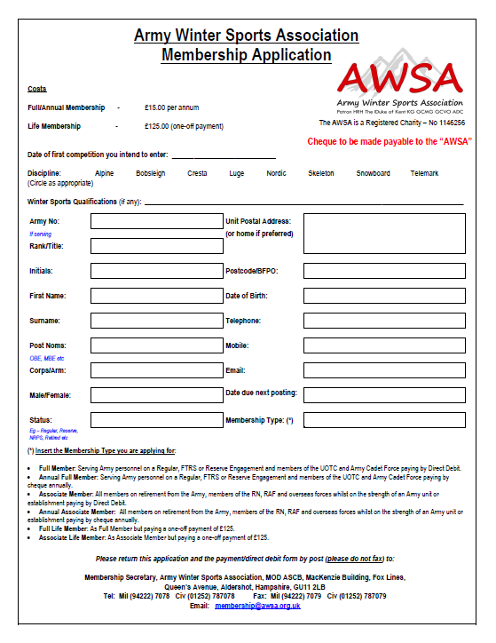

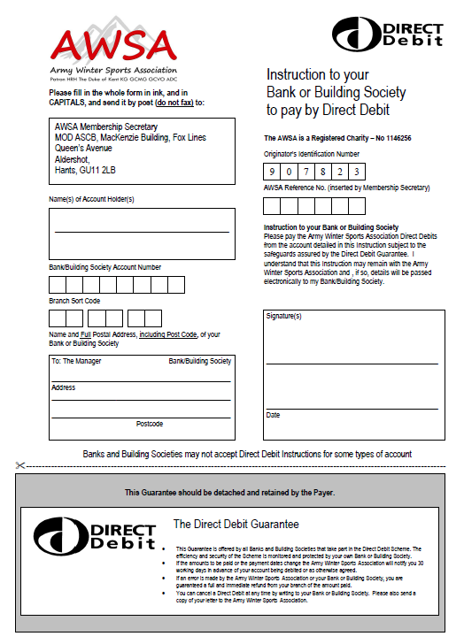
Annex B to
AISC/RI1/AI18/19
Dated 3 Oct 18

ATHLETE’S DECLARATION FOR TRAINING IN THE ARMY NOVICE ICE CAMP 2017

I, the undersigned, make the following declaration:

Last Name | First Name(s) | Service Number | Unit
Discipline*: 2-Man Bob / Luge / Skeleton |  | Gender*: Male/Female
*delete as applicable

1. EX RACING ICE 1 RULES, REGULATIONS AND PROCEDURES.

I understand and accept that my participation in Ex RACING ICE 1 is subject to my acceptance of all rules applicable and in connection with such event. I, therefore, agree to be submitted to such rules, regulations and procedures and to the jurisdiction of the organising committee of Ex RACING ICE 1 which is in charge of applying them.

2. ACKNOWLEDGEMENT OF RISKS.

I am fully aware and conscious of the potential risks involved in competing in ice sport activities and of the risk caused by speed and gravitational forces. I accept that the risk factors include environmental conditions and technical equipment. I am further aware that certain movements or actions cannot always be anticipated or controlled and therefore cannot be avoided or prevented through safety measures. Consequently, I know and accept that when I engage in such activities, my physical integrity and in extreme cases, even my life may be at risk. Furthermore, I know and accept that the above mentioned dangers linked with my participation may threaten third parties within the competition and training area. I will conduct my own inspection of training courses. I will immediately notify the Ex RACING ICE 1 officials of any safety concerns I may have. I understand that I am responsible for the choice of the appropriate equipment and of its condition, for the speed at which I slide and for the selection of my line through the course.

3. PERSONAL LIABILITY.

I understand that I may be found personally liable to third parties for damages arising from bodily injury or property damage they may suffer as a result of an occurrence linked with my participation in training. I agree that it is not the responsibility of Ex RACING ICE 1 staff to inspect or supervise my equipment.

4. RELEASE.

To the extent permitted by the applicable law, I release the AWSA, my National Association, and the organizers and their respective members, directors, officers, employees, volunteers, contractors and agents from any liability for any loss, injury, or damage suffered in relation to my participation in AWSA sanctioned training. This declaration shall also be binding on
my heirs, successors, beneficiaries, next of kin or assigns who might pursue any legal action in connection with the same

5. UNIT CONTACT DETAILS.

Unit Address | UIN | Duty Officer Mobile No. | Adjt Name | Adjt Telephone No.

6. NEXT OF KIN.

In order to meet Diplomatic Clearance information requirements, I confirm that my JPA-nominated Next of Kin (NoK) details are as follows below:

Name | Relationship | Contact Details (phone number only)

7. EHIC DETAILS.

In the event of an emergency, it may be necessary to pass EHIC information to the local medical services to secure treatment for you. Please enter the details from your EHIC below:

Name | Given Names | Date of Birth | Personal ID No. | ID No. of the Institution | ID No. of the card | Expiry Date

8. ICE SPORTS INSURANCE.

In the event of an emergency, it may be necessary to pass ice sports insurance cover information to the local medical services to secure treatment for you. Please enter the details from your policy documentation below:

Name of the Policyholder | Name of Insurer | Policy No. | Emergency Medical Contact Telephone No.

9. ATHLETE’S DECLARATION.

I understand that all details will be held by the Ex RACING ICE 1 Comd and that they will be treated in confidence and used only in the event of an emergency for the provision of medical assistance or military casualty reporting. I have read and understood the above Athlete's Declaration.

Signature: _____________________________________

Print Name: ____________________________________

Date: ____________

All brakemen and women for 2-man bobsleigh should have attended a novice training camp but this is not essential.
2017DIN10-006 Berlin Infantry Brigade Memorial Trust Fund.
JSP 462, Part 1, Chapter 7.
AGAI Volume 1, Chapter 5 (Sport).
JSP 456 Volume 2, Chapter 7.
JSP 752 Chapter 5, Section 4.
JSP 752 Chapter 3.
JSP 456, Volume 2, Chapter 7.
JSP 751, Vol 1, Part 1.

