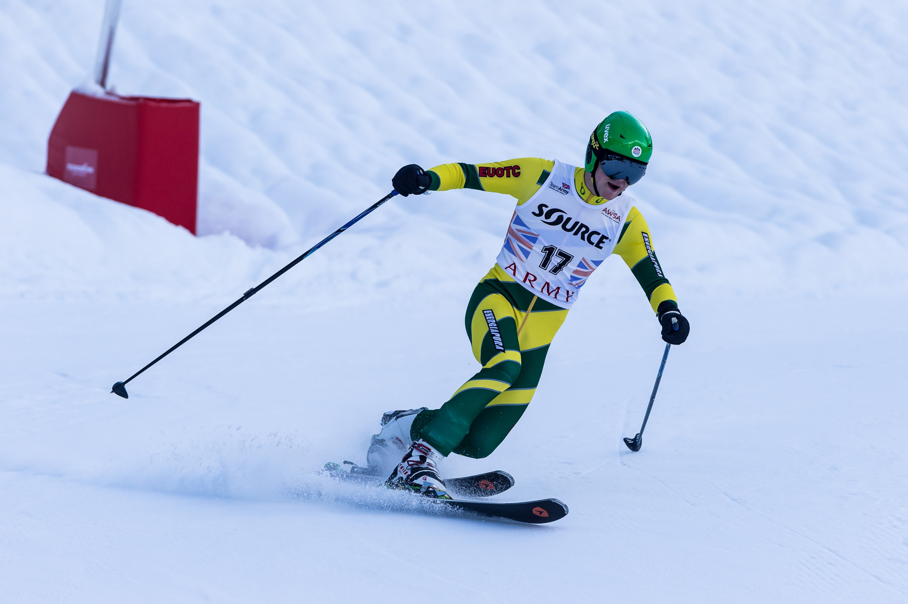
Ex TELEMARK TITAN 2019
The British, Royal Navy & Army Telemark Ski Championships

Pralognan-La-Vanoise, FRANCE, 12-24 Jan 19
For more info 2018DIN10-031 at: https://www.awsa.org.uk/telemark/
Contact: Maj Rich Wright – telemark@awsa.org.uk

