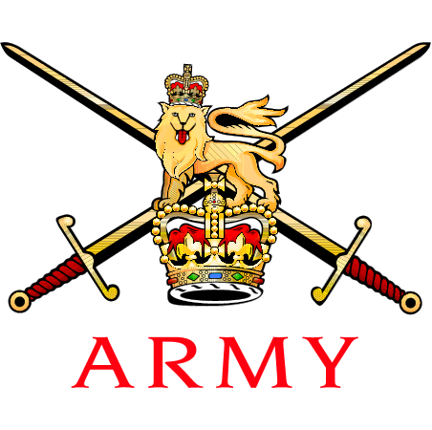
 | Captain D Austin  203 Ysbyty’r Maes (Cymreig)(Gwirfoddolwyr)  203 (Welsh) Field Hospital (Volunteers) AR Centre Gabalfa Avenue Llandaff North CARDIFF CF14 2HX | 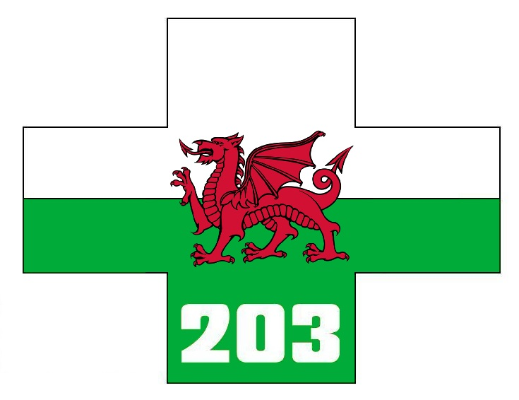
See Distribution | Reference: AMSSU/RSC/18  Date: 20 Aug 18

CALLING NOTICE – FIRST ARMY MEDICAL SERVICES ROLLER SKI CHAMPIONSHIPS 2018: 28 OCT 18

REFERENCE:

A. CHURCHILL UEI: 32UALS
B. JSP 752 Tri-Service Regulations For Allowances - Part 2
C. 2017DIN10-023 - Travel at Public Expense for Army Sport
D. WESSEX BIATHLON FESTIVAL 2018

- Introduction. The aim of this Calling Notice is to invite all AMS Nordic skiers and potential Nordic skiers to the first AMS Roller-Ski championships which be held 28 Oct 18 at Castle Combe race circuit in Wiltshire. These championships will run in conjunction to the festival at reference D.

- Background. To improve the AMS representation at the Army Nordic Skiing these championships are the culmination of several roller ski training weekends. The roller ski instruction will be delivered by British Association of Snowsport Instructors (BASI) and AMS experienced skiers.

- Training Aim. The aim of the day is to:

  - Provide through year training focus.

  - Provide incremental training progression and a means of assessing that progression e.g. entering the various roller ski competitions throughout the year.

  - Provide a technique ‘master class’ to maximise limited ‘on-snow’ time later in the year.

  - Attract novice skiers with a positive, progressive and developmental ‘club’ environment.

Co-ordinating Instructions

- Location. Castle Combe Circuit is situated to the west of the market town of Chippenham in the South West of England. The circuit regularly hosts motor-racing events and has also hosted both cycle and running races. The circuit has an excellent tarmac surface ideal for roller-skiing. The circuit is close to the M4 motorway and well signposted from all routes. Full details can be found at reference D.

- Programme.

TIME | EVENT
09:30 — 10:00 | Course open for training and inspection
10:30 | 12 km Men Sprint
11:30 | 6 km Women & Junior Sprint
11:30 | 3 km Novice, Youth & Junior Youth Sprint
— | Lunch
13:30 | Laser Biathlon Pairs Sprint Relay Heats
15:30 | Prize Giving

- Attendance. Attendance is open to all ranks and level of skiers within the AMS. Attendees are to complete the entry form at reference D and sent direct to Mr Bob Anderson. Capt Danny Austin is to be copied into all entries at danny.austin561@mod.gov.uk

- Dress. Dress is civilian sports/running kit. All kit must be presentable and serviceable.

- Equipment. Attendees are to bring with them the following equipment:

  - Running Kit
  - Spare Running Kit
  - Cycle Helmet (essential otherwise participant will not be able to take part)
  - Knee, elbow and wrist pads (essential).
  - Luminous Vest (if held)
  - Water Bottle(s)
  - Nordic Skiing Gloves (essential) Cycle gloves will suffice.
  - Sun glasses/impact specs (essential)
  - Wash Kit
  - First Aid kit including Savlon and gravel rash dressings
  - Towel
  - Civ Clothes
  - MOD 90

- If personnel have their own equipment, then they are to bring that with them due to limited number of boots, skis and poles currently available.

- Refreshments. Light refreshments (tea, coffee or juice) will be available on Sun during the breaks although all attendees are encouraged to bring water bottles or hydrations packs and fluids.

- Feeding. Castle Combe has a restaurant which can be used at personal cost for lunch and snacks.

- Costs. The cost of attendance is to be borne as follows:

  - CHURCHILL UEI. The UEI for this event is at Reference A.

  - T&S Costs. Roller Skiing is currently not recognised as an Army Sport and therefore T&S costs for attendees are to be borne by the parent unit in accordance with both References B and C.

  - RSD’s. For Reserve units, the allocation of the Trg Category in regards to RSDs is an individual unit responsibility.

  - Daily Subsistence. Claims for any costs relating to Daily Subsistence for this training lay with individual unit direction and in accordance with Reference B.

- Part One Orders. All personnel attending are to ensure that their names appear on Part One Orders.

- Accommodation. There is no service accommodation at Castle Combe race course.

- Transport. Transport provision remains a parent unit /individual responsibility.

RISK ASSESMMENT

- A Risk Assessment for this trg activity can be found at Annex A.

CONDUCT AND DISCIPLINE

- Attendees are reminded that throughout the training they are representing the AMS within the local area. All personnel are to ensure the highest levels of behaviour at all times. The undersigned is empowered to RTU any individual, at their personal cost for a disciplinary matter.

(Original Signed)

D Austin
Capt

Annexes:

A. Risk Assessment

Enclosures:

WESSEX BIATHLON FESTIVAL FLYER

Distribution:

AMS Unit 2ICs

DMG 2ICs

DMRC

RCDM

OC AMS Recruiting

Copy To:

Chairman AMS Winter Sports

Chairman AMS Skiing

DCOS 2 Med X

AMS Unit COs

DMG COs

CO HQ AMS

Adjt - HQ AMS

Adjt 203 Fd Hosp

CRSM

