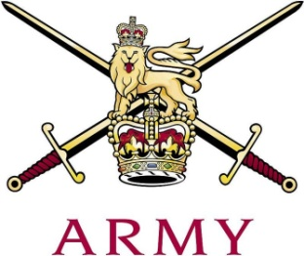
ARMY CRESTA

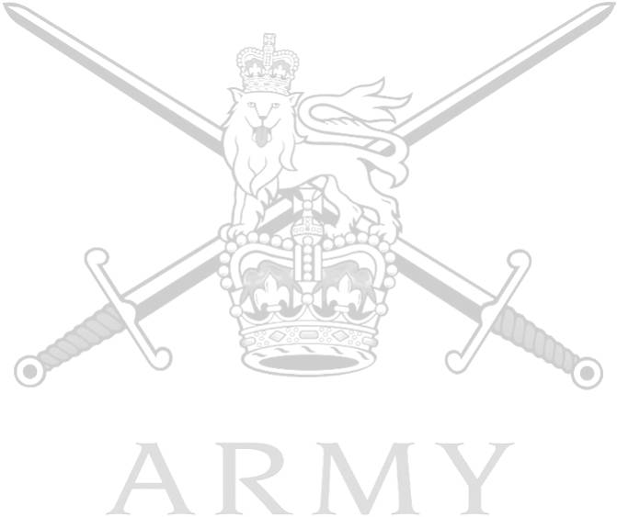
Scots Guards Cup

29th January 2018

 |  |  | 1st  Course | 2nd  Course | 3rd Course | Total
1 | Capt T. Wythe | The Royal Lancers | 55.18 | 54.46 | 55.54 | 165.18
2 | Maj P. Chishick | The Life Guards | 57.31 | 56.39 | 57.77 | 171.47
3 | CSjt T.C. Armon-Jones | The Rifles | 58.28 | 57.51 | 58.75 | 174.54
4 | LCoH R.J. Tonkin | The Blues & Royals | 58.88 | 57.84 | 58.02 | 174.74
5 | Maj R.M. Morgan | Royal Wessex Yeomanry | 59.64 | 59.74 | 59.05 | 178.43
6 | Capt S. Pryor | King's Royal Hussars | 60.28 | 59.73 | 58.62 | 178.63
7 | Lt J.C. Palmer-Tomkinson | Grenadier Guards | 59.93 | 59.51 | 60.12 | 179.56
 | Capt K.G. Gardner | The Royal Yeomanry | 59.84 | Fall(TH)
 | Capt F. Cairns | The Royal Scots Dragoon Guards | Fall(S)

Fastest Time of Race: Capt T. Wythe 54.46

