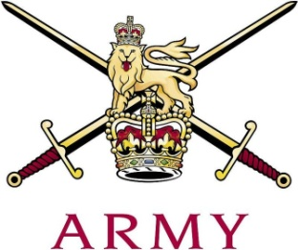
ARMY CRESTA

The Novice Cup 2018

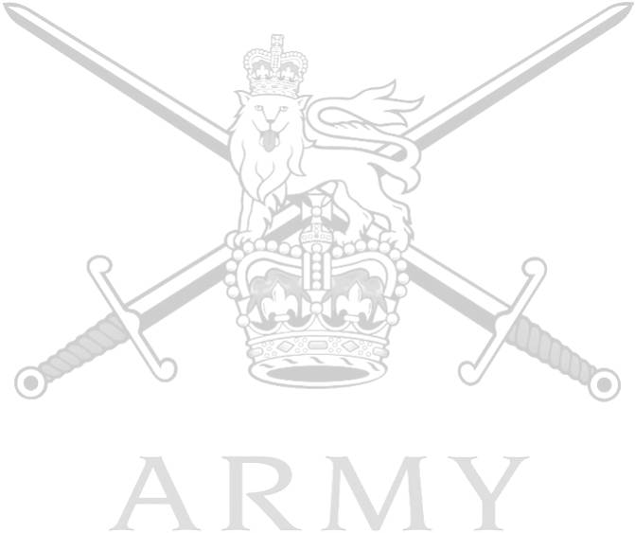
 |  |  | 1st | 2nd | 3rd | Grand Total
1 | Tpr D.M. McNally | The Blues & Royals | 51.59 | 49.76 | 54.20 | 155.55
2 | Lt F.C.N. Ide | Grenadier Guards | 52.07 | 52.80 | 50.83 | 155.70
3 | Lt G.A.D. Marriott | The Royal Lancers | 54.94 | 52.96 | 53.15 | 161.05
4 | Ct C.P. Onslow | The Blues & Royals | 56.12 | 54.02 | 54.55 | 164.69
5 | Lt T.C.W. Gray | The Royal Lancers | 54.75 | 55.92 | 54.85 | 165.52
6 | Lt F.L.H. Critchlow | Queen's Royal Hussars | 55.25 | 54.11 | 57.11 | 166.47
7 | LCpl J.N. Reuter | The Life Guards | 57.48 | 55.47 | 54.20 | 167.15
8 | Gdsm S.A. Charman | Grenadier Guards | 58.50 | 55.16 | 55.12 | 168.78
9 | Tpr E.J.C. Treadwell | Honourable Artillery Company | 58.98 | 58.70 | 54.98 | 172.66
10 | Cpl A.L. Couling | Queen's Royal Hussars | 60.39 | 56.44 | 56.48 | 173.31
11 | Tpr S.T.R. Godwin | Honourable Artillery Company | 59.49 | 57.95 | 57.25 | 174.69
12 | Lt F.G.E.H. Howard-Keyes | The Life Guards | 57.79 | 60.19 | 58.19 | 176.17
13 | LCpl C.P. Selcraig | King's Royal Hussars | 60.89 | 61.51 | 57.31 | 179.71
14 | LCpl S.V. Gaughan | The Royal Scots Dragoon Guards | 60.25 | 59.68 | 61.60 | 181.53
15 | Tpr J. Fletcher | The Royal Lancers | 61.64 | 60.44 | 61.71 | 183.79
16 | Tpr T.D.T. Cassidy | Honourable Artillery Company | 63.50 | 59.81 | 62.94 | 186.25
 | Capt A.L.G. Clarke | Royal Artillery | 58.59 | Fall (S)
 | Lt A.A.J. Nicholson | King's Royal Hussars | Fall (S)
 | LCpl D.J. Roberts | King's Royal Hussars | Fall (S)
 | Ct J.P. Fry | Queen's Royal Hussars | Fall (S)
 | Gdsm J. Heywood | Grenadier Guards | Fall (S)
 | Tpr D.H.R. Jenkins | Honourable Artillery Company | Fall (S)
 | LCpl A.C. Kerman | Royal Army Medical Corp | Fall (S)

