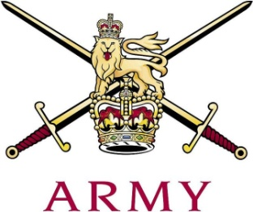
ARMY CRESTA

The 17th/21st Lancer Cup - Inter-Regimental Pairs 2018

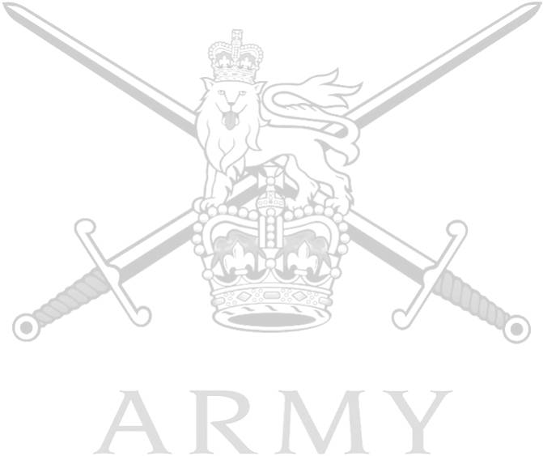
 |  |  |  |  |  |  |  |  |  |  |  | 1st |  |  | 2nd |  |  | 3rd |  |  | Grand Total
 | 1 |  | Capt T. Wythe |  |  |  |  | The Royal Lancers |  |  | 43.51 |  |  | 43.65 |  |  | 44.59
 |  |  | Capt S.R. White |  |  |  |  |  |  |  | 52.77 |  |  | 52.64 |  |  | 54.34 |  |  | 291.50
 | 2 |  | Lt J.C. Palmer-Tomkinson |  |  |  |  | Grenadier Guards |  |  | 46.60 |  |  | 46.52 |  |  | 47.45
 |  |  | Lt F.C.N. Ide |  |  |  |  |  |  |  | 52.07 |  |  | 52.80 |  |  | 50.83 |  |  | 296.27
 | 3 |  | LCoH R.J. Tonkin |  |  |  |  | The Blues & Royals |  |  | 48.32 |  |  | 46.53 |  |  | 47.84
 |  |  | Tpr D.M. McNally |  |  |  |  |  |  |  | 51.59 |  |  | 49.76 |  |  | 54.02 |  |  | 298.24
 | 4 |  | Capt F. Cairns |  |  |  |  | The Royal Scots Dragoon Guards |  |  | 48.32 |  |  | 48.06 |  |  | 47.73
 |  |  | LCpl S.V. Gaughan |  |  |  |  |  |  |  | 60.25 |  |  | 59.68 |  |  | 61.60 |  |  | 325.64
 | 5 |  | Lt G.A.D. Marriott |  |  |  |  | The Royal Lancers |  |  | 54.94 |  |  | 52.96 |  |  | 53.15
 |  |  | Lt T.C.W. Gray |  |  |  |  |  |  |  | 54.75 |  |  | 55.92 |  |  | 54.85 |  |  | 326.57
 | 6 |  | Tpr S.T.R. Godwin |  |  |  |  | Honourable Artillery Company |  |  | 59.49 |  |  | 57.95 |  |  | 57.25
 |  |  | Tpr E.J.C. Treadwell |  |  |  |  |  |  |  | 58.98 |  |  | 58.70 |  |  | 54.98 |  |  | 347.35

