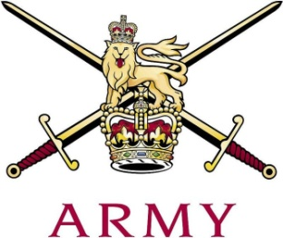
ARMY CRESTA

25th January 2018

Junction Handicap 2018
 |  |  | H'cap |  | 1st | 2nd |  | 3rd | Net Total
1 | Tpr D.M. McNally | The Blues & Royals | 6.5 | 51.59 |  | 49.76 | 48.97 |  |  | 130.82
2 | Lt F.C.N. Ide | Grenadier Guards | 7.5 | 52.07 |  | 52.80 | 50.83 |  |  | 133.20
3 | Gdsm S.A. Charman | Grenadier Guards | 10.0 | 58.50 |  | 55.16 | 55.12 |  |  | 138.78
4 | Lt J.C. Palmer-Tomkinson | Grenadier Guards | 0.5 | 46.60 |  | 46.52 | 47.45 |  |  | 139.07
5 | Lt F.L.H. Critchlow | Queen's Royal Hussars | 9.0 | 55.25 |  | 54.11 | 57.11 |  |  | 139.47
6 | Lt G.A.D. Marriott | The Royal Lancers | 7.0 | 54.94 |  | 52.96 | 53.15 |  |  | 140.05
7 | Maj R.M. Morgan | Royal Wessex Yeomanry | 0.5 | 47.54 |  | 46.96 | 47.72 |  |  | 140.72
8 | LCoH R.J. Tonkin | The Blues & Royals | 0.5 | 48.32 |  | 46.53 | 47.84 |  |  | 141.19
9 | Ct C.P. Onslow | The Blues & Royals | 7.5 | 56.12 |  | 54.02 | 54.55 |  |  | 142.19
10 | Capt S. Pryor | King's Royal Hussars | 0.5 | 48.80 |  | 47.53 | 47.74 |  |  | 142.57
11 | Capt F. Cairns | The Royal Scots Dragoon Guards | 0.5 | 48.32 |  | 48.06 | 47.73 |  |  | 142.61
12 | LCpl J.N. Reuter | The Life Guards | 8.0 | 57.48 |  | 55.47 | 54.20 |  |  | 143.15
13 | Lt T.C.W. Gray | The Royal Lancers | 7.0 | 54.75 |  | 55.92 | 54.85 |  |  | 144.52
14 | Tpr S.T.R. Godwin | Honourable Artillery Company | 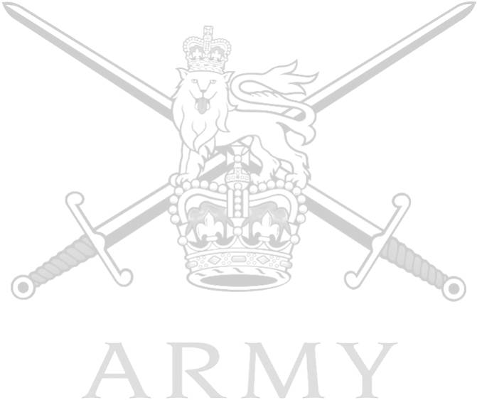  10.0 | 59.49 |  | 57.95 | 57.25 |  |  | 144.69
15 | Capt S.R. White | The Royal Lancers | 5.0 | 52.77 |  | 52.64 | 54.34 |  |  | 144.75
16 | Cpl A.L. Couling | Queen's Royal Hussars | 9.0 | 60.39 |  | 56.44 | 56.48 |  |  | 146.31
17 | LCpl C.P. Selcraig | King's Royal Hussars | 11.0 | 60.89 |  | 61.51 | 57.31 |  |  | 146.71
18 | LCpl S.V. Gaughan | The Royal Scots Dragoon Guards | 11.0 | 60.25 |  | 59.68 | 61.60 |  |  | 148.53
19 | Lt F.G.E.H. Howard-Keyes | The Life Guards | 9.0 | 57.79 |  | 60.19 | 58.19 |  |  | 149.17
20 | Tpr E.J.C. Treadwell | Honourable Artillery Company | 7.0 | 58.98 |  | 58.70 | 54.98 |  |  | 151.66
21 | Tpr T.D.T. Cassidy | Honourable Artillery Company | 11.0 | 63.50 |  | 59.81 | 62.94 |  |  | 153.25
22 | Tpr J. Fletcher | The Royal Lancers | 10.0 | 61.64 |  | 60.44 | 61.71 |  |  | 153.79
 | Capt A.L.G. Clarke | Royal Artillery | 10.5 | 58.59 |  | Fall (S)
 | Capt K.G. Gardner | The Royal Yeomanry | 0.5 | 47.12 |  | 46.44
 | Lt A.A.J. Nicholson | King's Royal Hussars | 7.0 | Fall (S)
 | LCpl D.J. Roberts | King's Royal Hussars | 12.0 | Fall (S)
 | Ct J.P. Fry | Queen's Royal Hussars | 8.0 | Fall (S)
 | Gdsm J. Heywood | Grenadier Guards | 10.0 | Fall (S)
 | Tpr D.H.R. Jenkins | Honourable Artillery Company | 12.0 | Fall (S)
 | LCpl A.C. Kerman | Royal Army Medical Corp | 11.0 | Fall (S)

Fastest Time of Race: Capt K.G. Gardner 46.44

