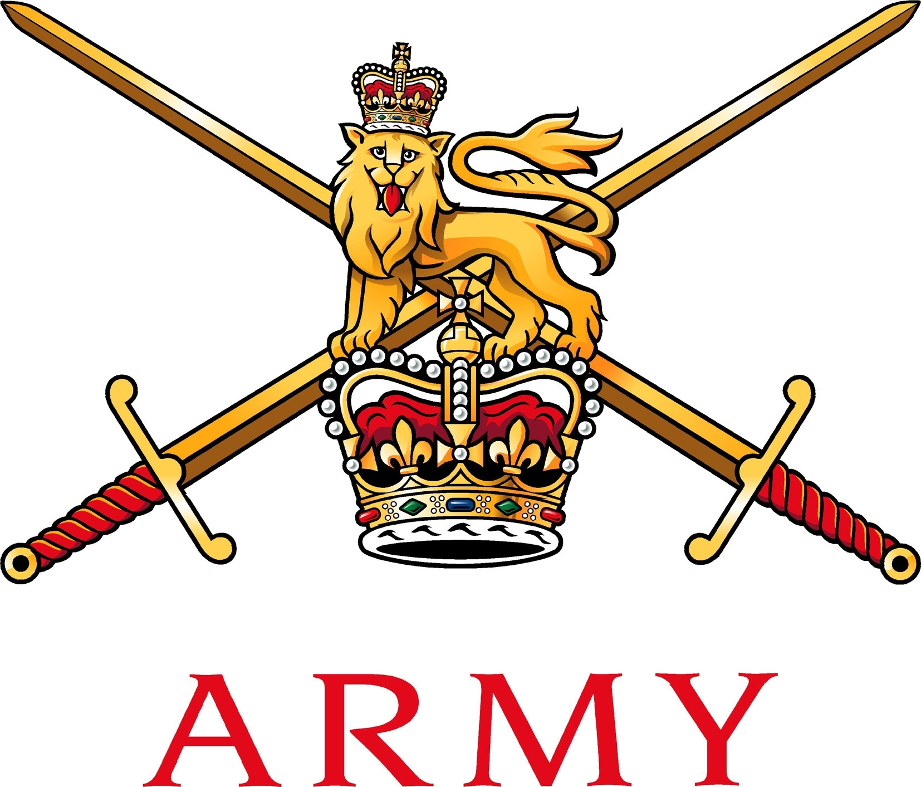
Army Sport Control Board
Mackenzie Building
Fox Lines
Aldershot
GU11 2LB

Telephone: Civilian (01252) 787058
Military (94222) 7058
Facsimile: Civilian (01252) 787060
Military (94222) 7060
DII: ASCB-COS@mod.uk
E-mail: acos@ascb.uk.com (preferred)

ASCB 428.1

Capt A Millar AMS
22 Field Hospital
Keogh Barracks
Ash Vale
Aldershot
Surrey
GU12 5RQ 14 Sep 16
AUTHORITY TO UNDERTAKE WINTER SPORTS ACTIVITY – Ex PORTON SERPENT THE ARMY MEDICAL SERVICES SKI CHAMPIONSHIPS 2017

References:

A. Your letter dated 1 Sep 2016.
B. JSP 660.
C. 2015DIN07-122 Army European Winter Activity Instruction (note this will be updated and replaced in Summer 16).
D. 2014DIN10-054 Army Overseas Sports Visits.
E. JSP 375, Pt 2, Vol 1, Chap 2, 8 and 40.
F. The Management of Health and Safety at Work Regulations 1999 No. 3242, Regulation 3
G. JSP 375, Pt 2, Vol 1 (Jan 16).
H. Land Forces Frago 01 to OPO 14/002 – Risk to Life

1. Thank you for your email at Ref A, requesting authority for the Army Medical Services Nordic and Alpine Ski Champs to take place in FRANCE between 26 Jan and 9 Feb 17. Authority is granted for up to 400 competitors to travel in accordance with Ref B. The new Winter Activity Instruction (Ref C) for 2016 has not yet been published and you are reminded to review it carefully before departing on your Exercise.

2. Participation in Winter Sports Activity is vested in the Chain of Command and the OIC must ensure that those selected have been duly released, which will attract Duty Status. Nominal rolls must be updated prior to departure and all names published on Unit Part 1 Orders. You are advised that all members travelling to the event should carry a valid ID card, passport and relevant Visa.

3. All Winter Activity is initially approved by Sec Army Winter Sports and the OIC is to keep him informed of any changes. The maximum number of participants for each approved sports team is laid down in Ref B and D.

4. Diplomatic and Staff Clearance are to be applied for in accordance with Ref C.

5. This event is classified as Individual Military Training and hence funding is permitted at Public Expense with Budgetary approval in accordance with Reference C. No claims can be made against the Representational Sports Travel Budget without additional authority from this office.

6. Insurance. Serving members of the party (including Army Reserves) are to be advised that the Armed Forces Compensation Scheme (JSP 765) provides compensation for illness, injury or death where caused wholly or partly by an individual’s service in the Armed Forces. Duty Status is no longer relevant in compensation cases; injuries sustained during sports events or in this case an overseas visit, will be assessed on the balance of probabilities that the injury was more likely than not to have been caused by service. As there will be potential for different interpretations of the applicability of JSP 765, all participating individuals are most strongly encouraged to ensure they have personal and third party liability insurance when participating in any Service sport.

7. Duty Holding. In accordance with References E, F and G, the OiC of the visit is to comply with the Safe System of Training and ensure the security of the party is considered and Host Nation customs observed. A comprehensive Event Instruction must be produced which must include a Risk Assessment (RA). This activity is categorised as Risk to Life (RtL) and in accordance with Ref H, the OiC is to take note of the Delivery Duty Holder (DDH) requirements and note that they assume responsibly for the Duty of Care of the event (from the deployment, during the event and returning to unit) and must ensure all activities are conducted within the parameters of the Safe Operating Envelope. The OiC must satisfy his/herself that National Governing Body safety rules apply and that risk is maintained As Low As Reasonably Practicable (ALARP).

8. Injury Reporting. In accordance with Ref F, all injuries (and near misses) must be reported to the Army Incident Notification Cell (AINC) using an Army Form 510 and copied to the Sec Army Winter Sports at ASCB.

9. Good Order and Discipline. Personnel on Winter Activity are representing the Army and there are significant reputational and diplomatic implications should there be any poor behaviour. Those in charge of the Exercise must stress the importance of good order and discipline in their Administration Orders and ensure that behaviour, both on and off the field of play is exemplary.

10. PXR. Please note that there is a specific requirement for a PXR to be completed and forwarded to the SO3 G3/7 PD Branch of your parent Regional Bde in order to comply with DIA cost capture requirements (separate Army Sports Lottery rules also apply however).

11. If any further advice or clarification is required, please contact the ASCB.

Original signed

SAJ DAVIS
Lieutenant Colonel
ACOS ASCB

Copy to:
Sec BAG SB*
Sec AWSA*
HQ AMS*
11 Inf Bde SO3 PD*

